**Chapter 1**

**NumPy**

**What are NumPy Arrays?**

NumPy is a Python package that stands for ‘Numerical Python’. It is the core library for scientific computing, which contains a powerful n-dimensional array object.

**Where is NumPy used?**

Python NumPy arrays provide tools for integrating C, C++, etc. It is also useful in linear algebra, random number capability etc. NumPy array can also be used as an efficient multi-dimensional container for generic data. Now, let me tell you what exactly is a Python NumPy array.

**Python NumPy Array:**Numpy array is a powerful N-dimensional array object which is in the form of rows and columns. We can initialize NumPy arrays from nested Python lists and access it elements. In order to perform these NumPy operations, the next question which will come in your mind is:

**How do I install NumPy?**

To install Python NumPy, go to your command prompt and type “pip install numpy”. Once the installation is completed, go to your IDE (For example: Jupyter Notebook) and simply import it by typing: “import numpy as np”

Moving ahead in python numpy tutorial, let us understand what exactly is a multi-dimensional numpy array.

Here, I have different elements that are stored in their respective memory locations. It is said to be two dimensional because it has rows as well as columns. In the above image, we have 3 columns and 4 rows available.

**How do I start NumPy?**

Let us see how it is implemented in Jupyter Notebook:

**Single-dimensional Numpy Array:**

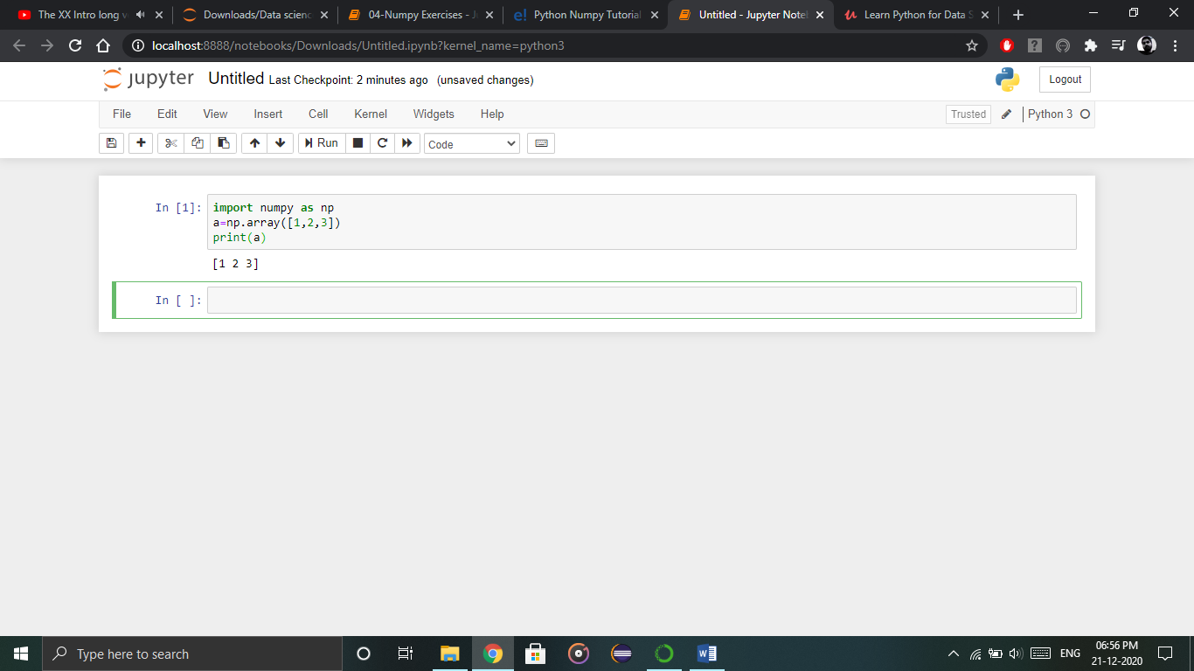

Output – [1 2 3]

**Multi-dimensional Array:**

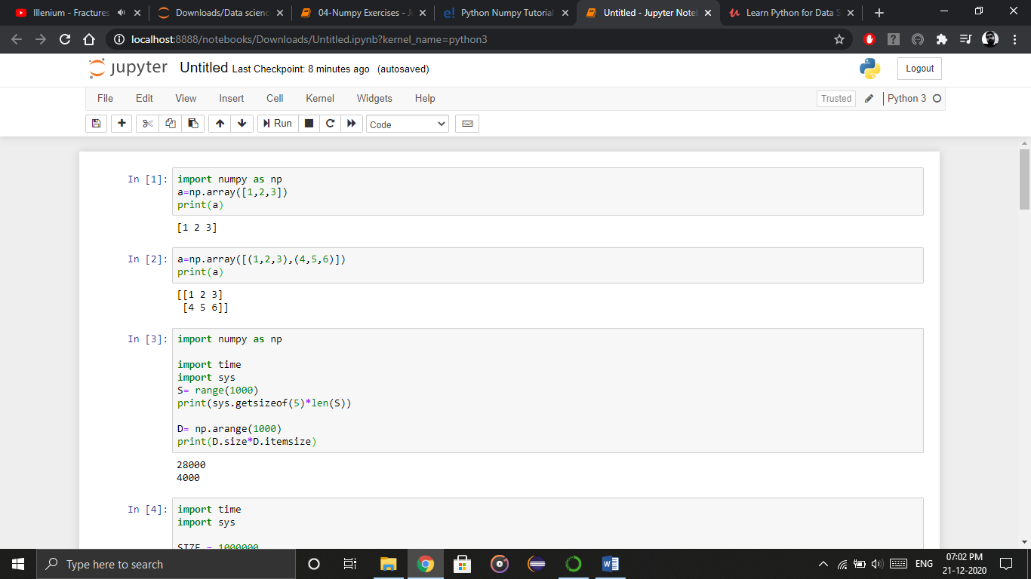

O/P – [[ 1 2 3]  
[4 5 6]]

**Python NumPy Array v/s List**

**Why NumPy is used in Python?**

We use python NumPy array instead of a list because of the below three reasons:

1. Less Memory
2. Fast
3. Convenient

The very first reason to choose python NumPy array is that it occupies less memory as compared to list. Then, it is pretty fast in terms of execution and at the same time, it is very convenient to work with NumPy. So these are the major advantages that Python NumPy array has over list. Don’t worry, I am going to prove the above points one by one practically in Jupyter Notebook. Consider the below example:

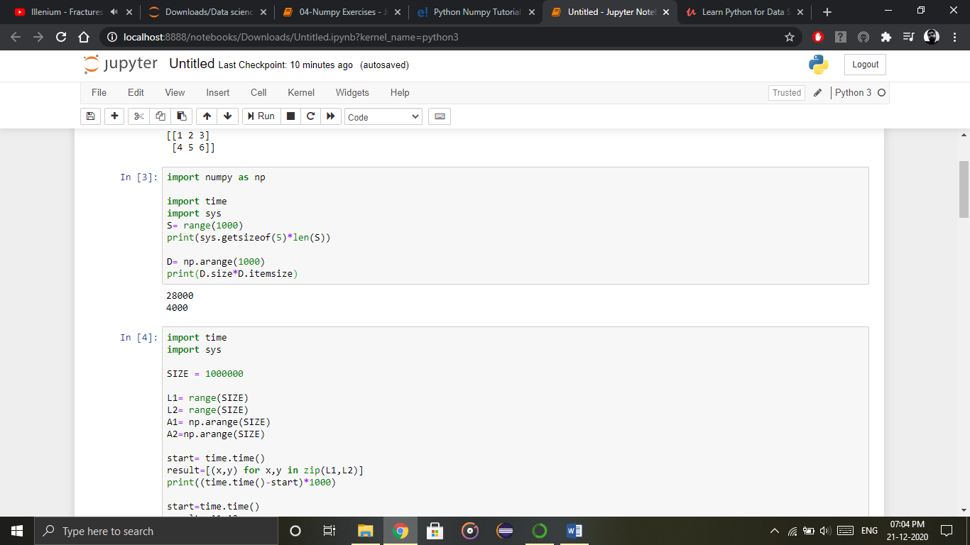

Output–  28000

4000

The above output shows that the memory allocated by list (denoted by S) is 14000 whereas the memory allocated by the NumPy array is just 4000. From this, you can conclude that there is a major difference between the two and this makes Python NumPy array as the preferred choice over list.

Next, let’s talk how python NumPy array is faster and more convenient when compared to list.

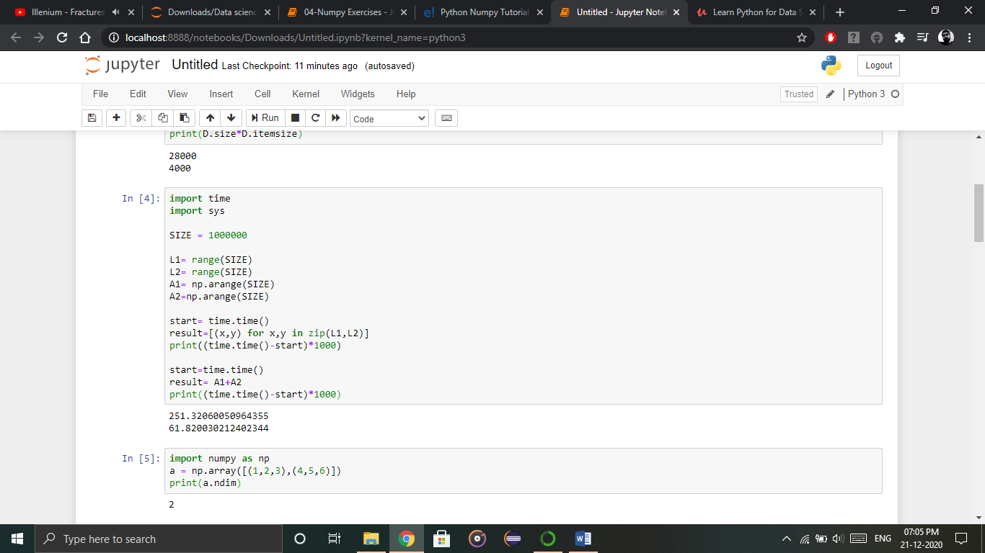

O/P – 251.32060050964355

61.820030212402344

**Python NumPy Operations**

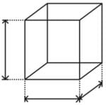

* **ndim**:  
  You can find the dimension of the array, whether it is a two-dimensional array or a single dimensional array. So, let us see this practically how we can find the dimensions. In the below code, with the help of ‘ndim’ function, I can find whether the array is of single dimension or multi dimension.

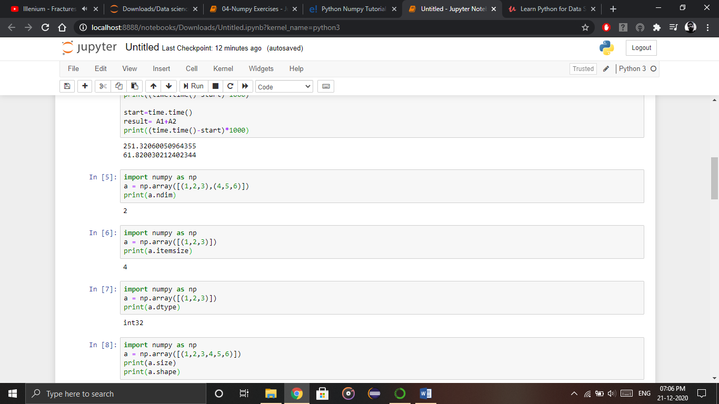

Output – 2

Since the output is 2, it is a two-dimensional array (multi dimension).

* **itemsize**:  
  You can calculate the byte size of each element. In the below code, I have defined a single dimensional array and with the help of ‘itemsize’ function, we can find the size of each element.



Output – 4

So every element occupies 4 byte in the above numpy array.

* **dtype:**  
  You can find the data type of the elements that are stored in an array. So, if you want to know the data type of a particular element, you can use ‘dtype’ function which will print the datatype along with the size. In the below code, I have defined an array where I have used the same function.

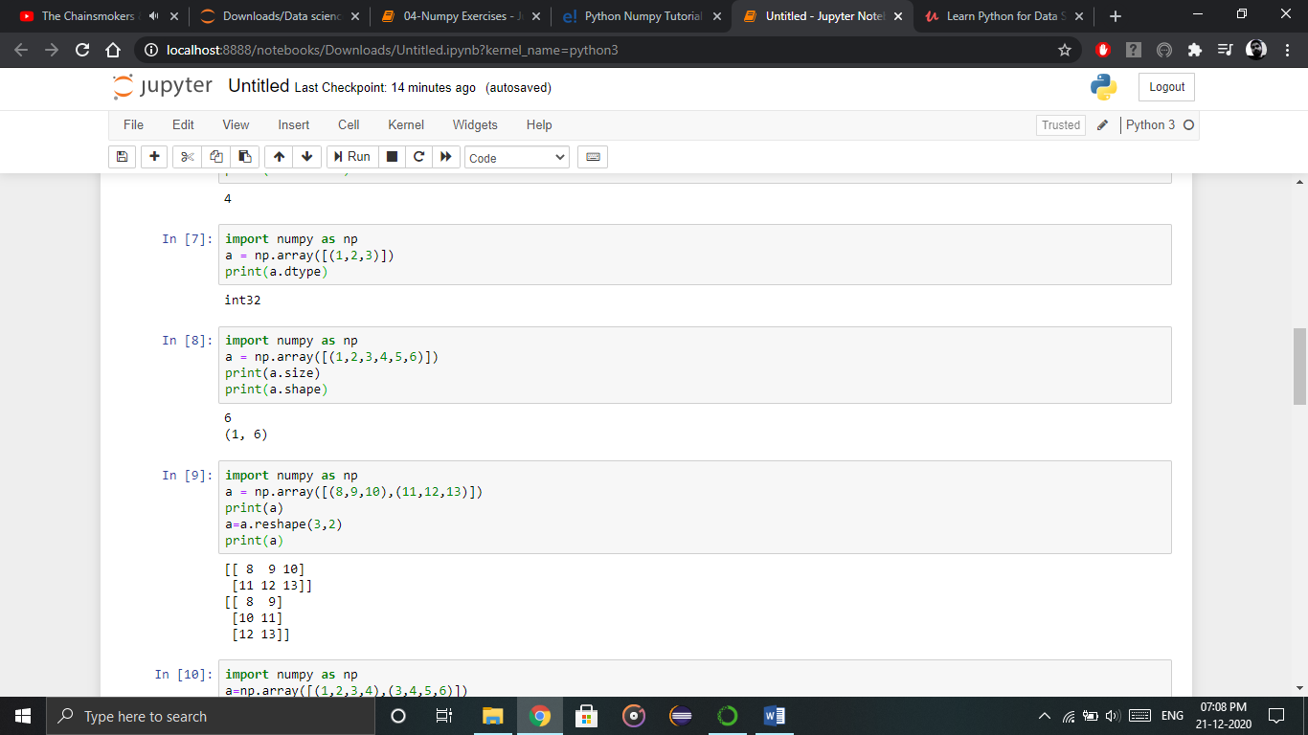

Output – int32

As you can see, the data type of the array is integer 32 bits. Similarly, you can find the size and shape of the array using ‘size’ and ‘shape’ function respectively.



Output – 6 (1,6)

Next, let us move forward and see what are the other operations that you can perform with python numpy module. We can also perform reshape as well as slicing operation using python numpy operation. But, what exactly is reshape and slicing? So let me explain this one by one in this python numpy tutorial.

* **Reshape:**  
  Reshape is when you change the number of rows and columns which gives a new view to an object. Now, let us take an example to reshape the below array:

As you can see in the above image, we have 3 columns and 2 rows which has converted into 2 columns and 3 rows. Let me show you practically how it’s done.



Output – [[ 8 9 10] [11 12 13]] [[ 8 9] [10 11] [12 13]]

* **Slicing:**  
  As you can see the ‘reshape’ function has showed its magic. Now, let’s take another operation i.e. Slicing. Slicing is basically extracting particular set of elements from an array. This slicing operation is pretty much similar to the one which is there in the list as well. Consider the following example:

Before getting into the above example, let’s see a simple one. We have an array and we need a particular element (say 3) out of a given array. Let’s consider the below example:

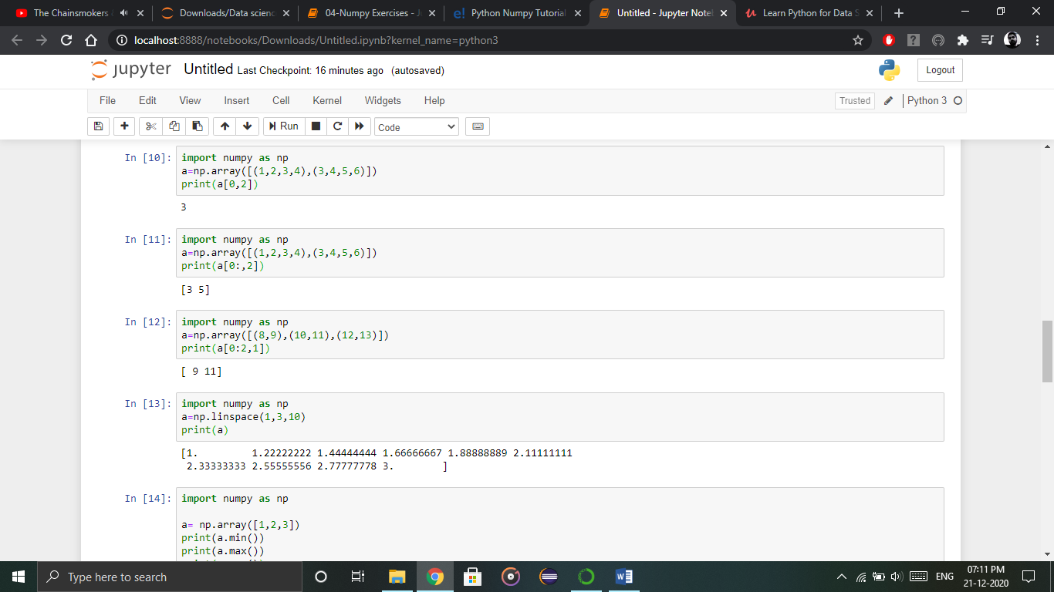

Output – 3

Here, the array(1,2,3,4) is your index 0 and (3,4,5,6) is index 1 of the python numpy array. Therefore, we have printed the second element from the zeroth index.  
Taking one step forward, let’s say we need the 2nd element from the zeroth and first index of the array. Let’s see how you can perform this operation:



Output – [3 5]

Here colon represents all the rows, including zero. Now to get the 2nd element, we’ll call index 2 from both of the rows which gives us the value 3 and 5 respectively.

Next, just to remove the confusion, let’s say we have one more row and we don’t want to get its 2nd element printed just as the image above. What we can do in such case?  
Consider the below code:



Output – [9 11]

As you can see in the above code, only 9 and 11 gets printed. Now when I have written 0:2, this does not include the second index of the third row of an array. Therefore, only 9 and 11 gets printed else you will get all the elements i.e [9 11 13].

* **linspace**   
  This is another operation in python numpy which returns evenly spaced numbers over a specified interval. Consider the below example:



Output – [ 1. 1.22222222 1.44444444 1.66666667 1.88888889 2.11111111 2.33333333 2.55555556 2.77777778 3. ]

As you can see in the result, it has printed 10 values between 1 to 3.

* **Max/min**  
  Next, we have some more operations in numpy such as to find the minimum, maximum as well the sum of the numpy array. Let’s go ahead in python numpy tutorial and execute it practically.

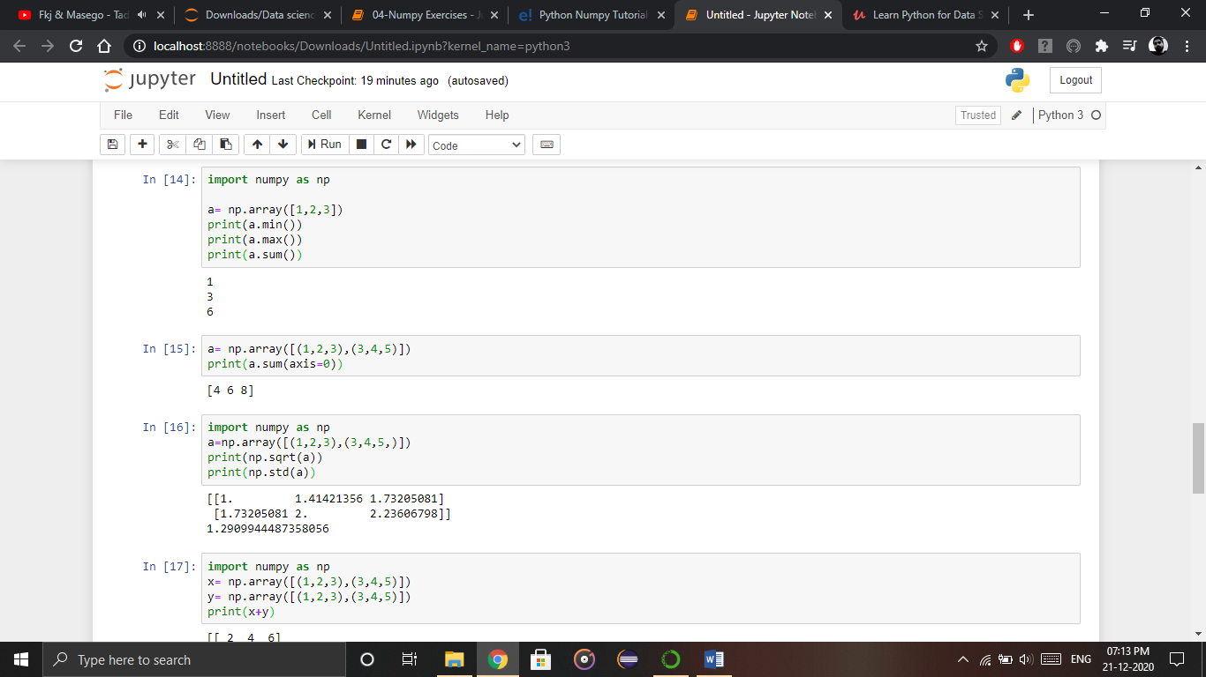

* Output – 1 3 6
* You must be finding these pretty basic, but with the help of this knowledge you can perform a lot bigger tasks as well. Now, let’s understand the concept of **axis** in python numpy.

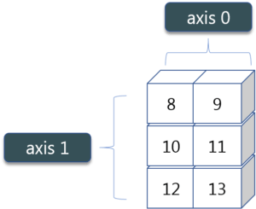

* As you can see in the figure, we have a numpy array 2*3. Here the rows are called as axis 1 and the columns are called as axis 0. Now you must be wondering what is the use of these axis?
* Suppose you want to calculate the sum of all the columns, then you can make use of axis. Let me show you practically, how you can implement axis in your Jupyter notebook:



Output – [4 6 8]

* Therefore, the sum of all the columns are added where 1+3=4, 2+4=6 and 3+5=8. Similarly, if you replace the axis by 1, then it will print [6 12] where all the rows get added.

**Square Root & Standard Deviation**

There are various mathematical functions that can be performed using python numpy. You can find the square root, standard deviation of the array. So, let’s implement these operations:

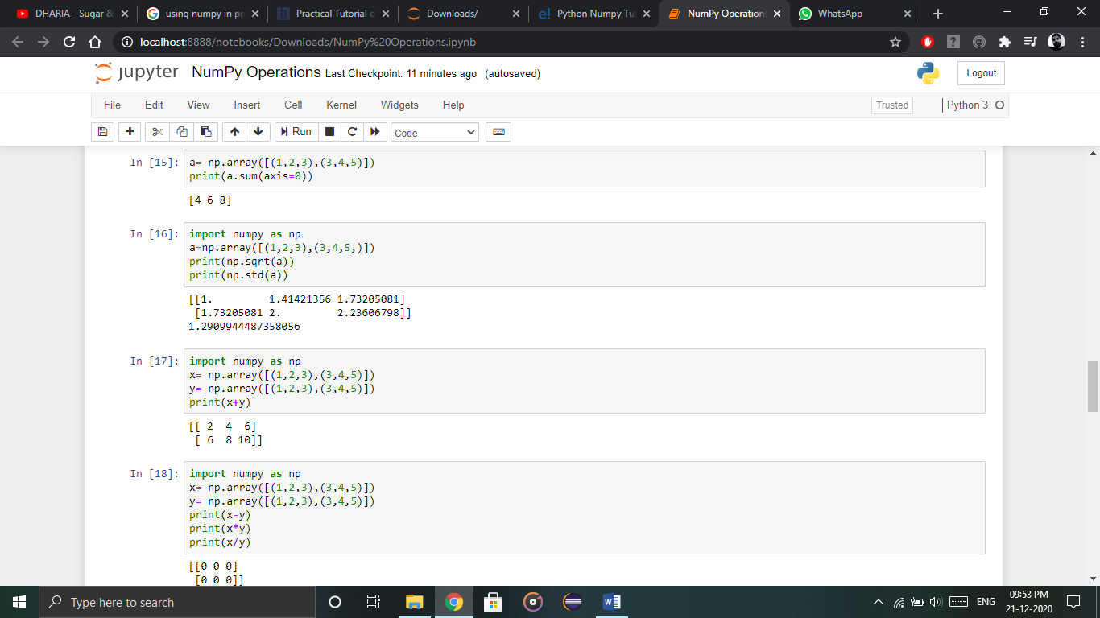

Output – [[ 1. 1.41421356 1.73205081]  
[ 1.73205081 2. 2.23606798]]  
1.29099444874

As you can see the output above, the square root of all the elements are printed. Also, the standard deviation is printed for the above array i.e how much each element varies from the mean value of the python numpy array.

* **Addition_Operation**  
  You can perform more operations on numpy array i.e addition, subtraction, multiplication and division of the two matrices. Let me go ahead in python numpy tutorial, and show it to you practically:

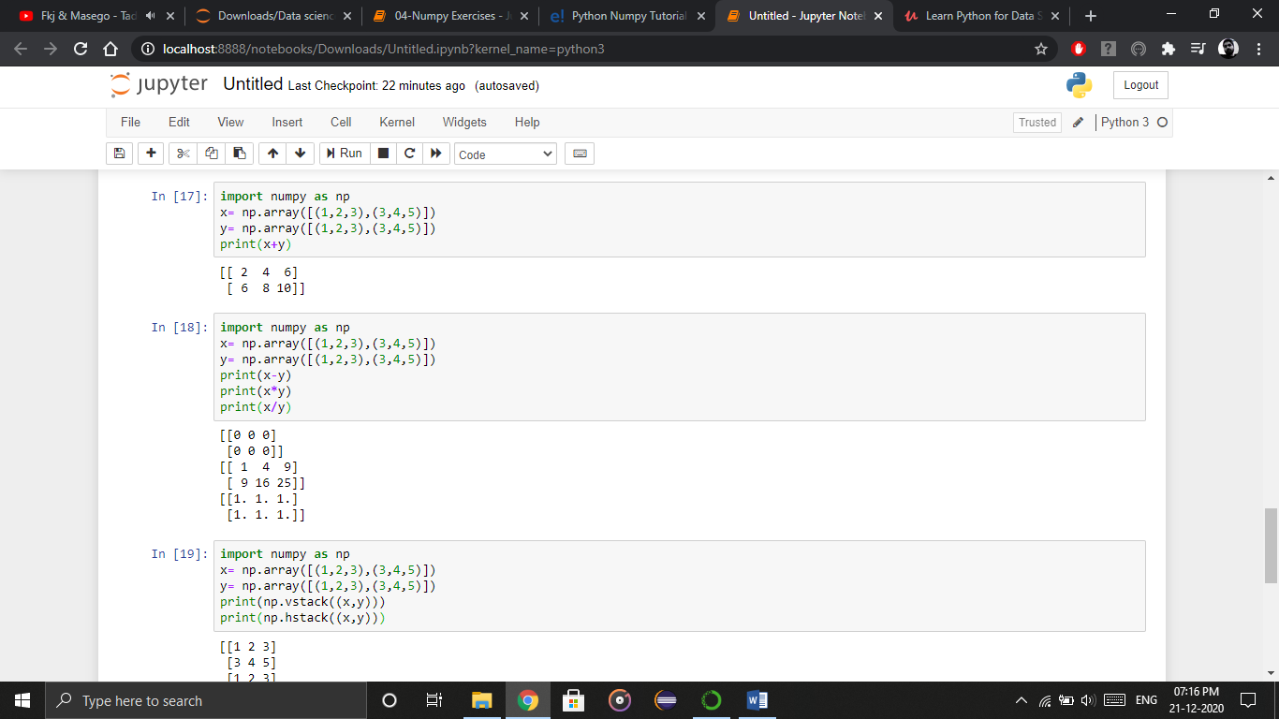

Output – [[ 2 4 6] [ 6 8 10]]

* This is extremely simple! Right? Similarly, we can perform other operations such as subtraction, multiplication and division. Consider the below example:



* Output – [[0 0 0] [0 0 0]]  
  [[ 1 4 9] [ 9 16 25]]  
  [[ 1. 1. 1.] [ 1. 1. 1.]]
* **Vertical_&_Horizontal_Stacking**  
  Next, if you want to concatenate two arrays and not just add them, you can perform it using two ways – *vertical stacking* and *horizontal stacking*. Let me show it one by one in this python numpy tutorial.

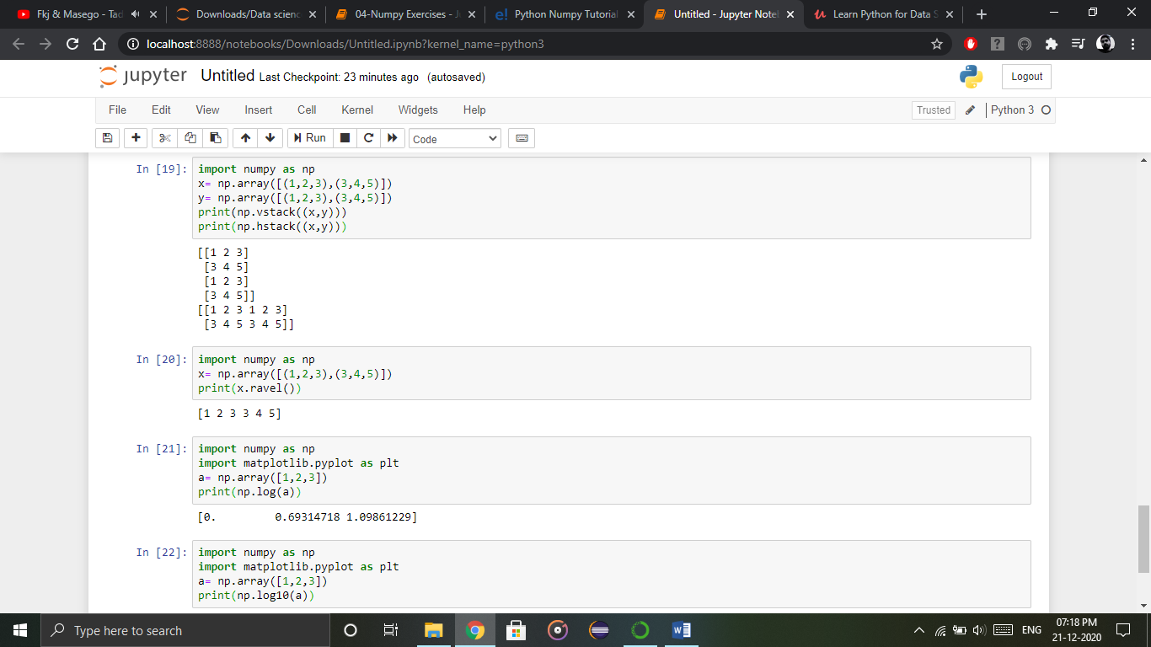

Output – [[1 2 3] [3 4 5] [1 2 3] [3 4 5]]  
[[1 2 3 1 2 3] [3 4 5 3 4 5]]

* **Ravel**  
  There is one more operation where you can convert one numpy array into a single column i.e *ravel*. Let me show how it is implemented practically:



Output – [ 1 2 3 3 4 5]

Let’s move forward in python numpy tutorial, and look at some of its special functions.

**Python Numpy Special Functions**

* There are various special functions available in numpy such as sine, cosine, tan, log etc. First, let’s begin with sine function where we will learn to plot its graph. For that, we need to import a module called matplotlib. To understand the basics and practical implementations of this module. Moving ahead with python numpy tutorial, let’s see how these graphs are plotted.

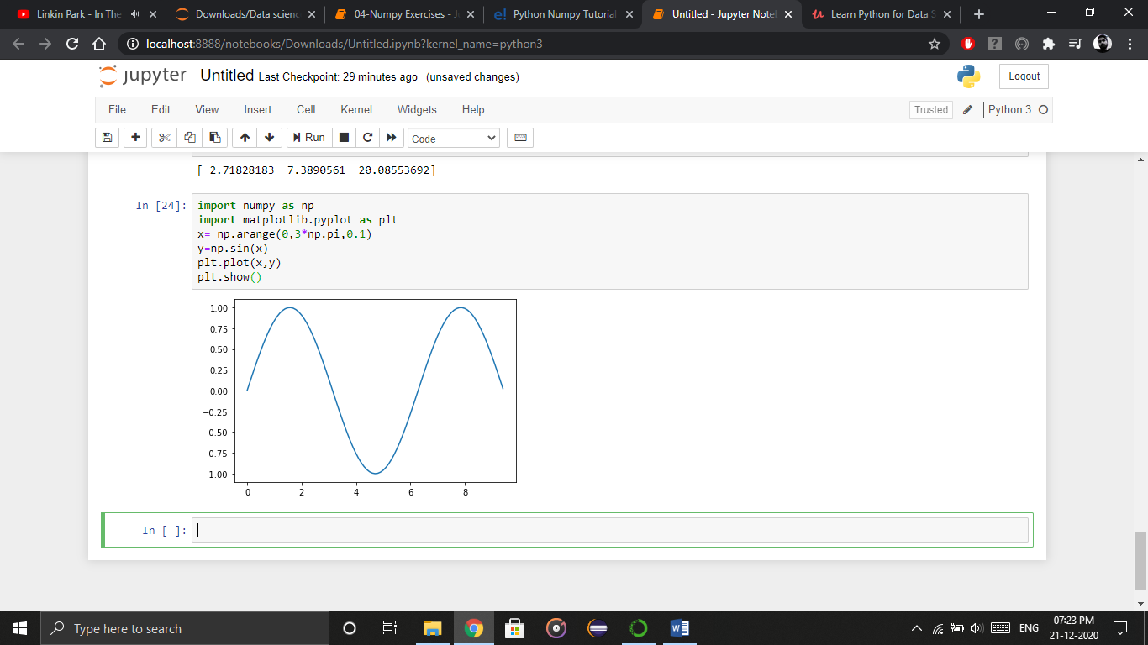

* Similarly, you can plot a graph for any trigonometric function such as cos, tan etc. Let me show you one more example where you can plot a graph of another function, let’s say ***tan****.*

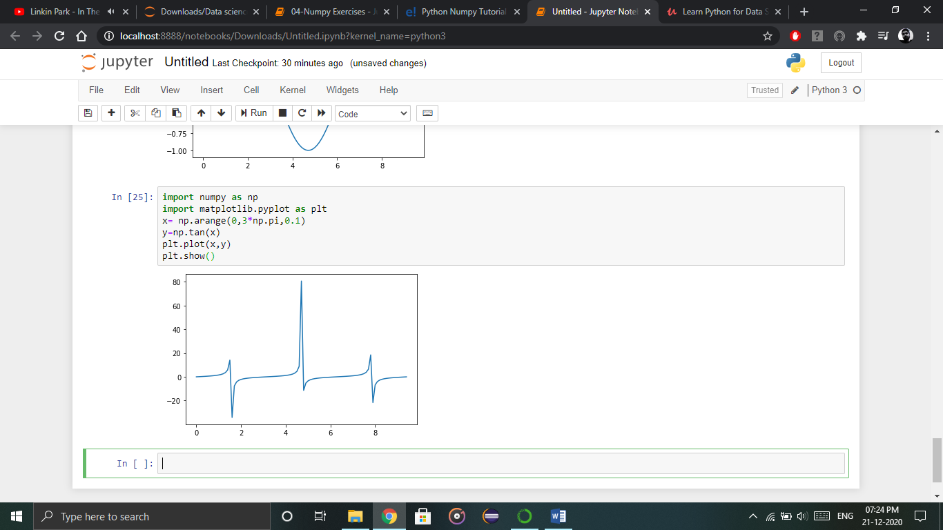

* Moving forward with python numpy tutorial, let’s see some other special functionality in numpy array such as exponential and logarithmic function. Now in exponential, the *e*value is somewhere equal to 2.7 and in log, it is actually *log base 10*.  When we talk about natural log i.e. log base e, it is referred as Ln. So let’s see how it is implemented practically:

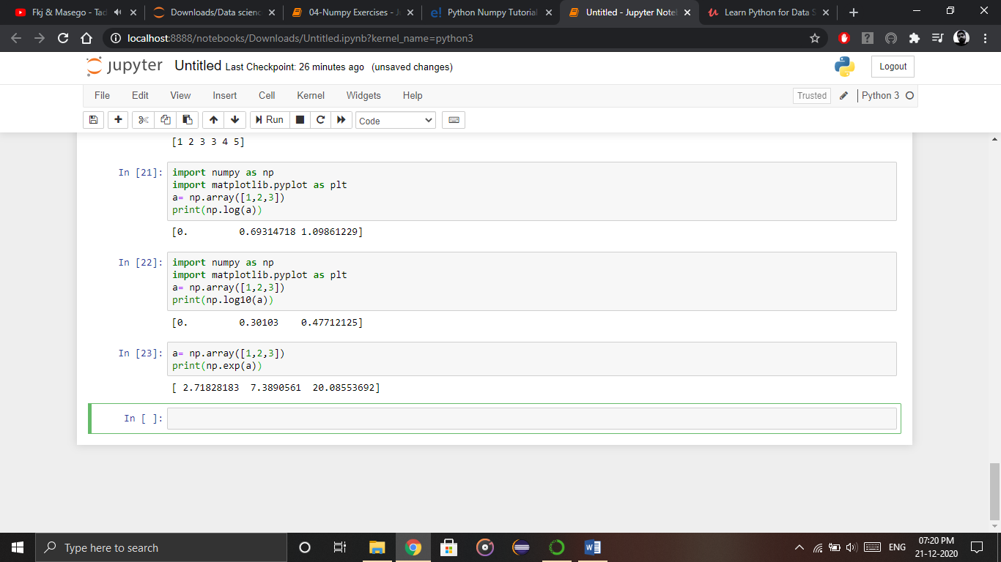

Output – [ 2.71828183   7.3890561   20.08553692]

* As you can see the above output, the exponential values are printed i.e *e* raise to the power 1 is *e,* which gives the result as 2.718… Similarly, *e* raise to the power of 2 gives the value somewhere near 7.38 and so on. Next, in order to calculate log, let’s see how you can implement it:



Output – [ 0.          0.69314718  1.09861229]

* Here, we have calculated natural log which gives the value as displayed above. Now, if we want log base 10 instead of Ln or natural log, you can follow the below code:



Output – [0.        0.30103      0.47712125]

**Practice Exercise on Numpy**

Go through the code and try to implement it in Jupyter Notebook. Output are given, you need to write the code to get that particular output printed on the screen.

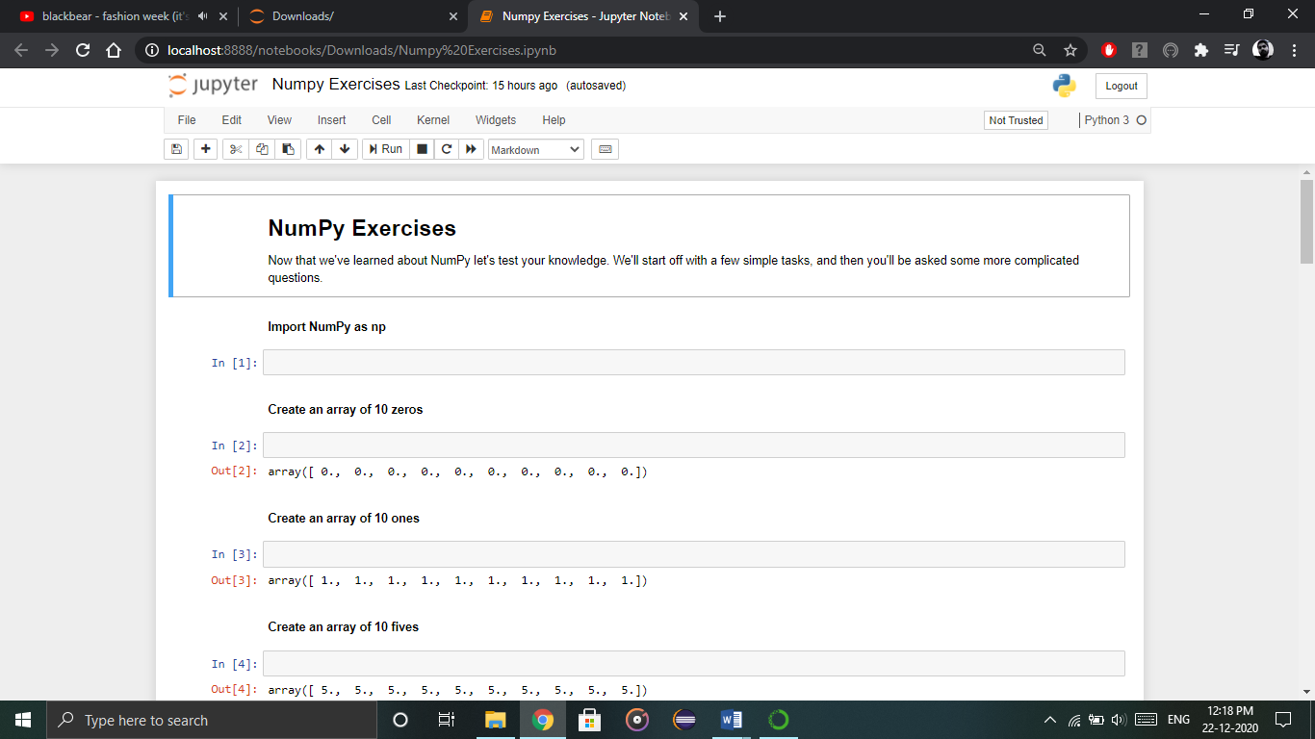

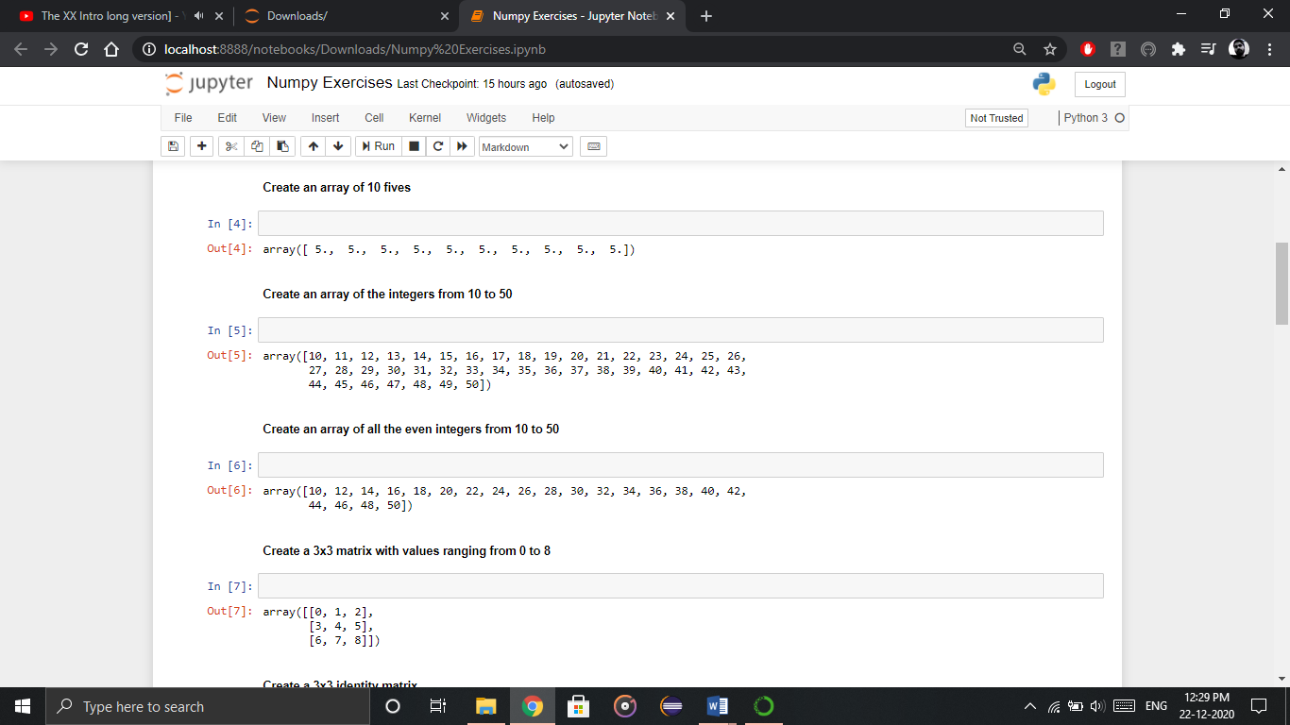

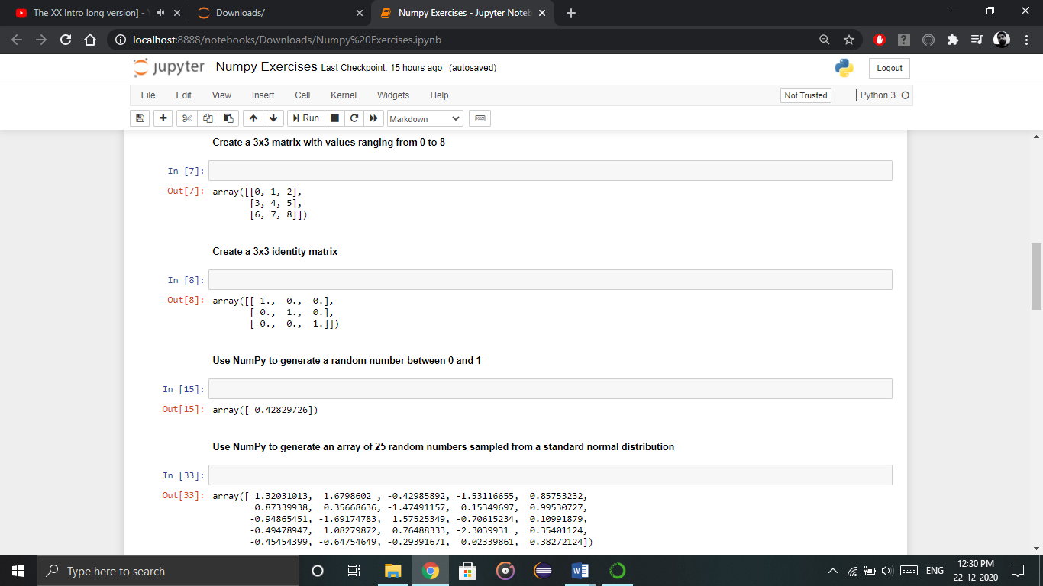

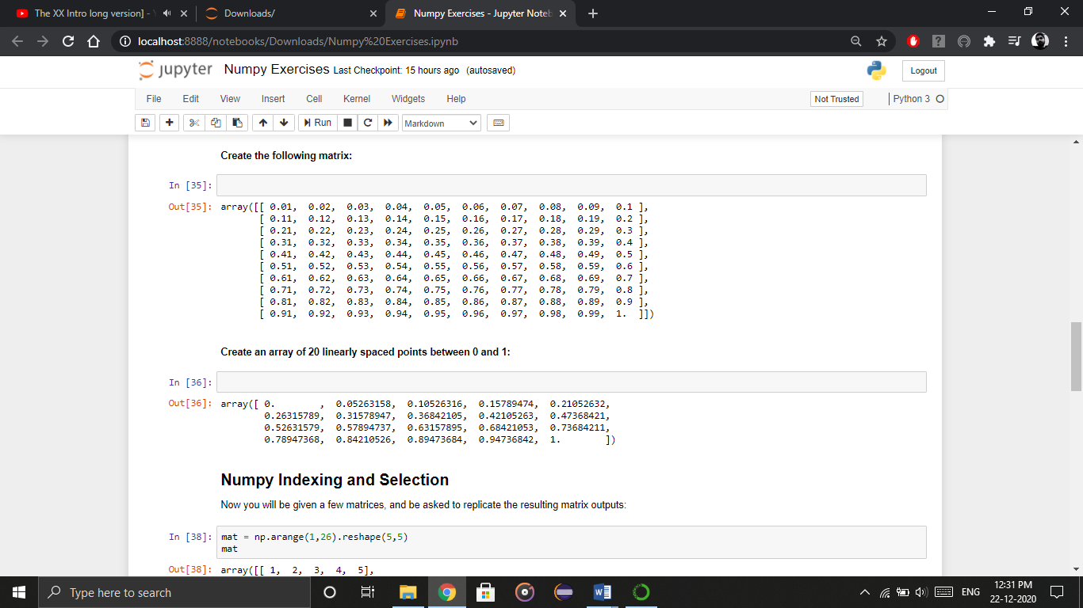

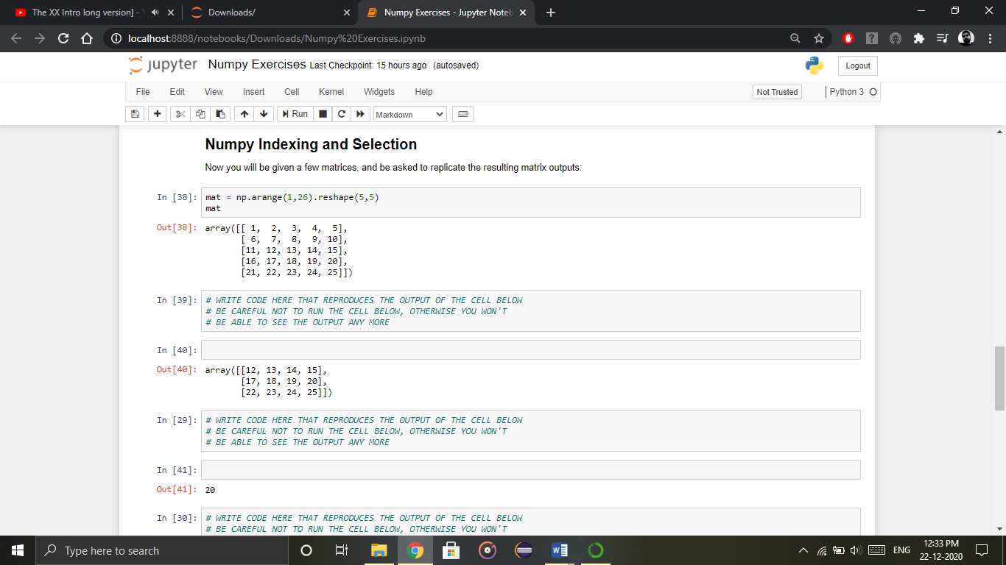

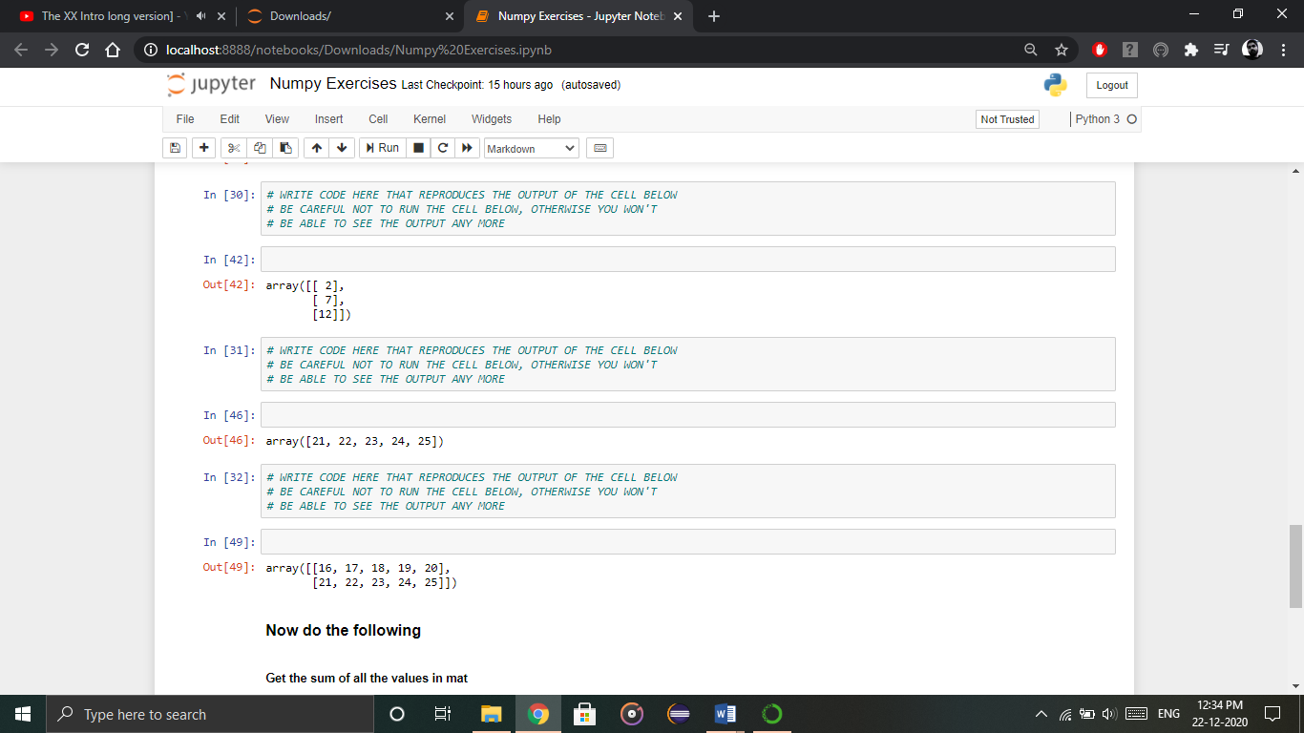

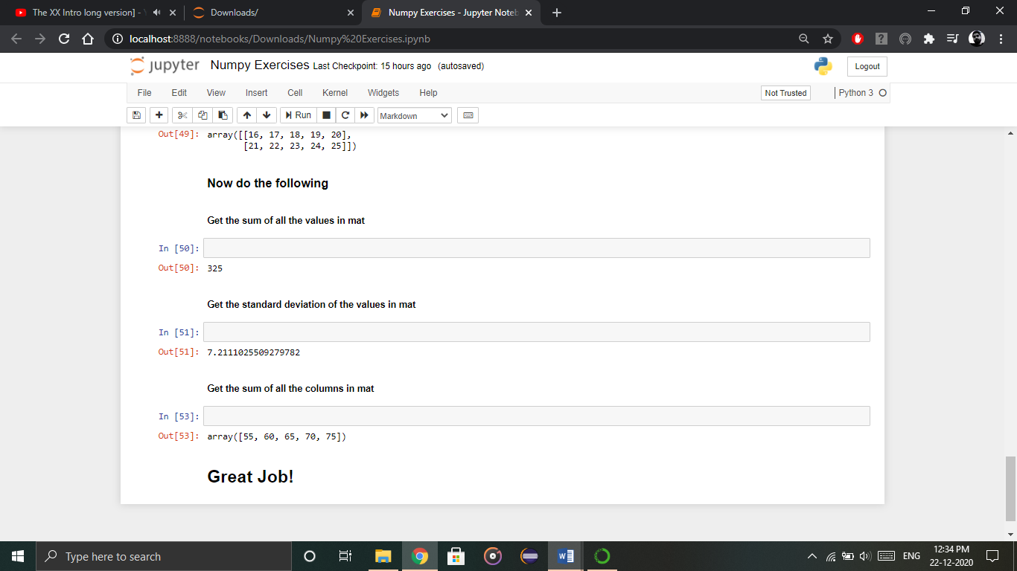

**Done!!**

**Exercise**

**MCQs**

1. There are various special ________ available in numpy such as sine, cosine, tan, log etc.
2. Variables
3. Functions
4. Classes
5. Objects
6. NumPy array can also be used as an efficient __________ container for generic data.
7. Single-dimensional
8. 2-Dimensional
9. 3-Dimensional
10. Multi-dimensional
11. This is another operation in python numpy which returns ____ spaced numbers over a specified interval.
12. Normally
13. Oddly
14. Evenly
15. Easily
16. _______ is basically extracting particular set of elements from an array.
17. Dicing
18. Reshaping
19. Linspace
20. Slicing
21. There is one more operation where you can convert one numpy array into a single column i.e _________.
22. Ravel
23. Vertical & Horizontal Stacking
24. Max/min
25. Dtype

**True or false**

1. Numpy array is a powerful N-dimensional array object which is in the form of rows and columns.
2. NumPy is a Python package that stands for ‘Numbers Python’.
3. NumPy array can also be used as an efficient multi-dimensional container for already made data.
4. Numpy is also useful in linear algebra, random number capability etc.
5. Python NumPy arrays does not provide tools for integrating C, C++, etc.

**Fill in the blanks**

Ravel, execution, memory, itemsize, list.

1. The very first reason to choose python NumPy array is that it occupies less ______ as compared to list.
2. It is pretty fast in terms of ________ and at the same time, it is very convenient to work with NumPy.
3. There are the major advantages that Python NumPy array has over ______.
4. With the help of ______ function, we can find the size of each element.
5. There is an operation where you can convert one numpy array into a single column i.e. ______.

**Answer in short**

1. What are NumPy Arrays?
2. Where is NumPy used?
3. How do I install NumPy?
4. Why NumPy is used in Python?
5. How to do vertical and horizontal scaling?

**Viva Questions**

1. What is Numpy?
2. Why NumPy is used in Python?
3. What does NumPy mean in Python?
4. Where is NumPy used?
5. How to import numpy in python?
6. How to create 1D Array ?
7. How to create 2D Array ?

**Chapter 2**

**Pandas**

**What is Python Pandas?**

Pandas is used for data manipulation, analysis and cleaning. Python pandas is well suited for different kinds of data, such as:

* Tabular data with heterogeneously-typed columns
* Ordered and unordered time series data
* Arbitrary matrix data with row & column labels
* Unlabelled data
* Any other form of observational or statistical data sets

**How to install Pandas?**

To install Python Pandas, go to your command line/ terminal and type “pip install pandas” or else, if you have anaconda installed in your system, just type in “conda install pandas”. Once the installation is completed, go to your IDE (Jupyter Notebook etc.) and simply import it by typing: “import pandas as pd”

Moving ahead in Python pandas tutorial, let’s take a look at some of its operations:

**Python Pandas Operations**

Using Python pandas, you can perform a lot of operations with series, data frames, missing data, group by etc. Some of the common operations for data manipulation are listed below:

### **Slicing the Data Frame**

In order to perform slicing on data, you need a data frame. Don’t worry, data frame is a 2-dimensional data structure and a most common pandas object. So first, let’s create a data frame.

Refer the below code for its implementation in Jupyter Notebook:

#### 

The code above will convert a dictionary into a pandas Data Frame along with index to the left. Now, let us slice a particular column from this data frame. Refer the image below:

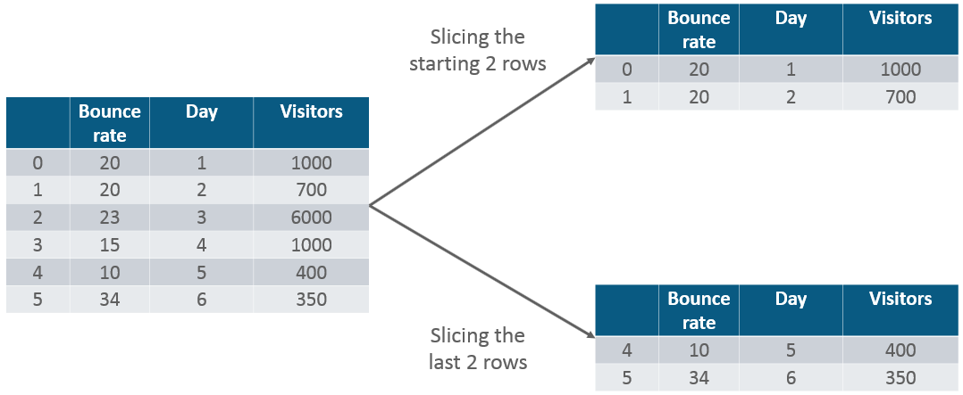

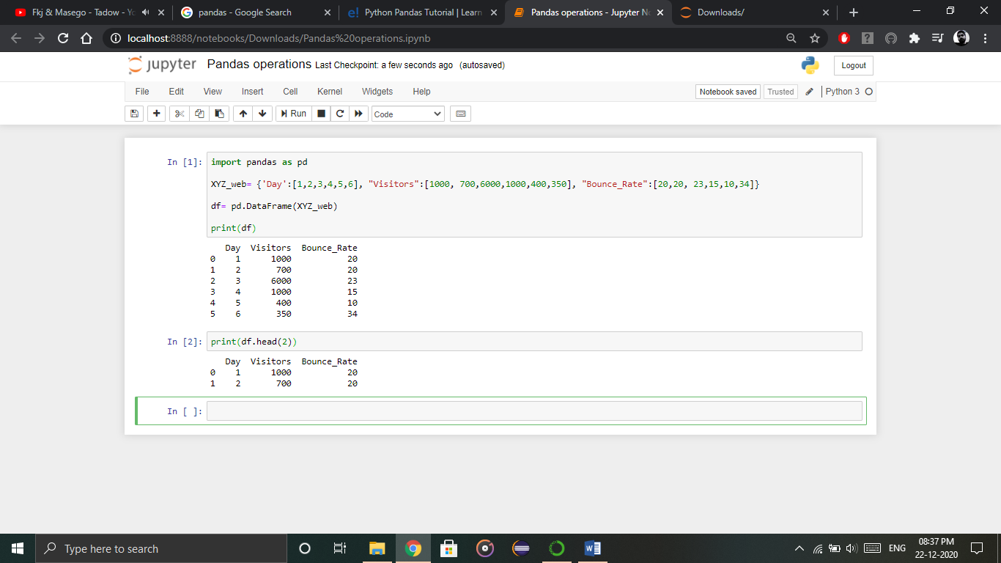

Similarly, if you want the last two rows of the data, type in the below command:

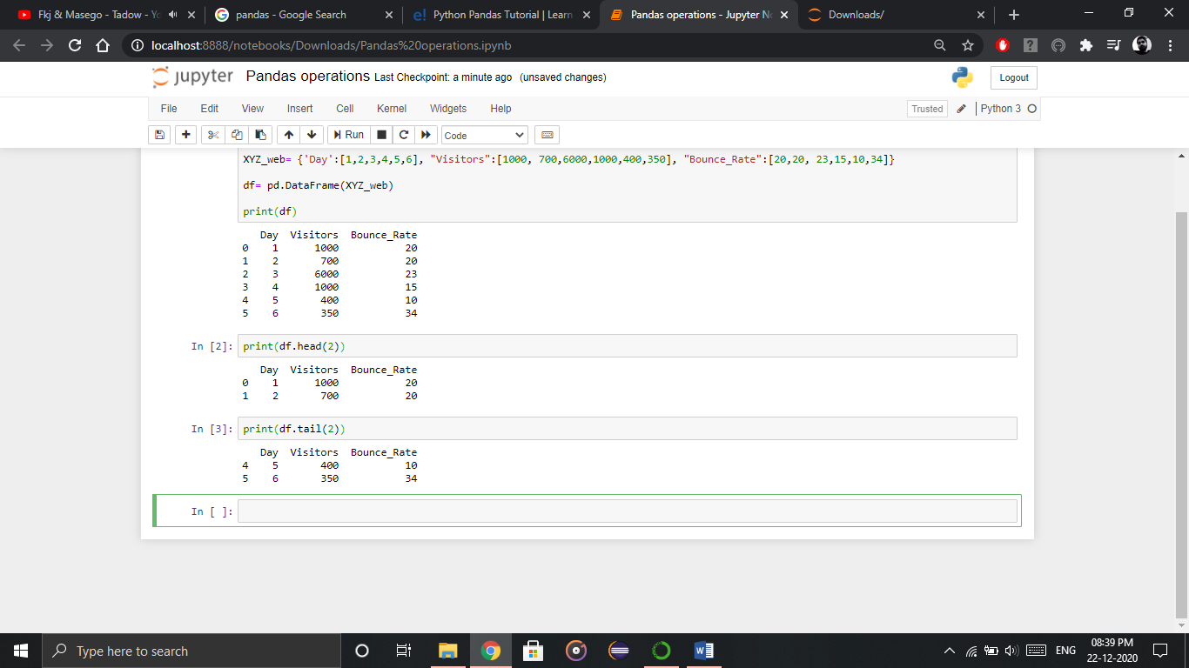

Next in Python Pandas tutorial, let us perform merging and joining.

### 

### **Merging & Joining**

In merging, you can merge two data frames to form a single data frame. You can also decide which columns you want to make common. Let me implement that practically, first I will create three data frames, which has some key-value pairs and then merge the data frames together. Refer the code below:

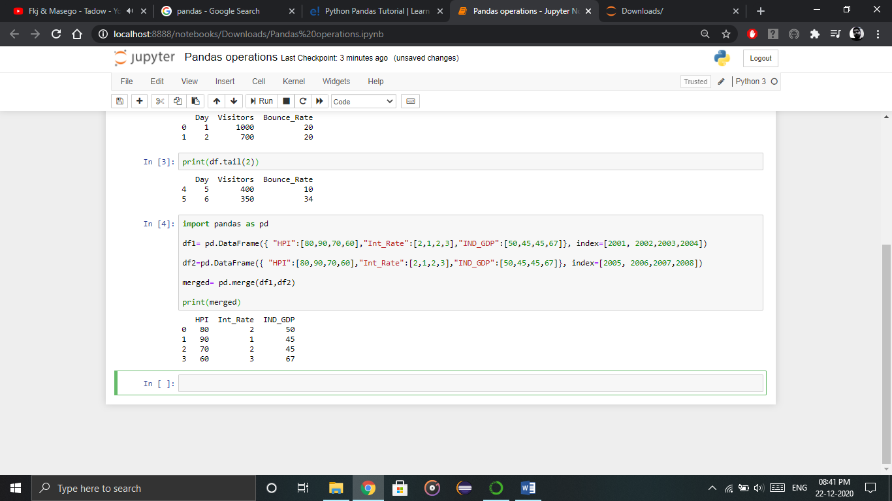

As you can see above, the two data frames has merged into a single data frame. Now, you can also specify the column which you want to make common. For example, I want the “HPI” column to be common and for everything else, I want separate columns. So, implement that practically:

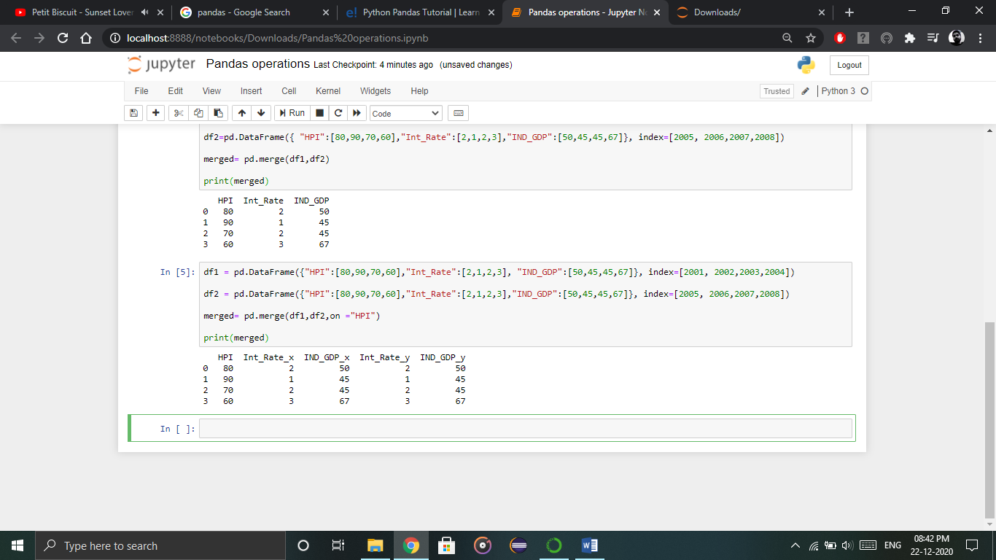

Next, let us understand **joining** in python pandas tutorial. It is yet another convenient method to combine two differently indexed dataframes into a single result dataframe. This is quite similar to the “merge” operation, except the joining operation will be on the “index” instead of  the “columns”. Let us implement it practically.

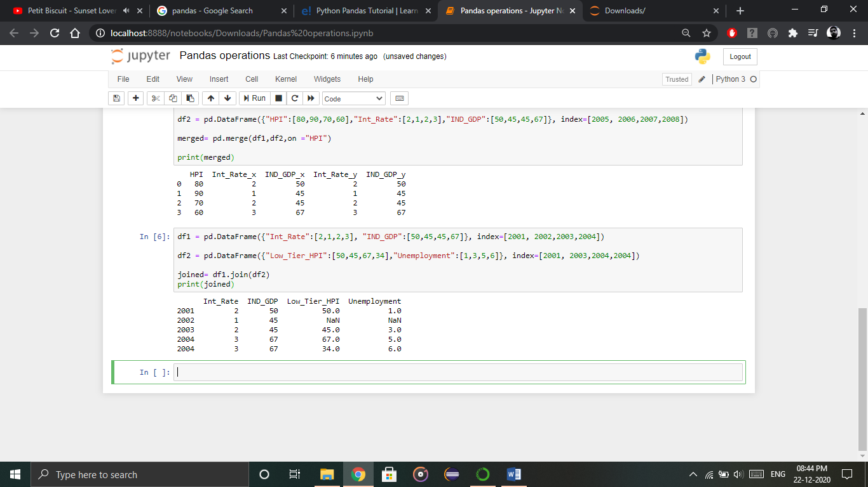

As you can notice in the above output, in year 2002(index), there is no value attached to columns “low_tier_HPI” and “unemployment”, therefore it has printed NaN (Not a Number). Later in 2004, both the values are available, therefore it has printed the respective values.

### **Concatenation**

Concatenation basically glues the dataframes together. You can select the dimension on which you want to concatenate. For that, just use “pd.concat” and pass in the list of dataframes to concatenate together. Consider the below example.

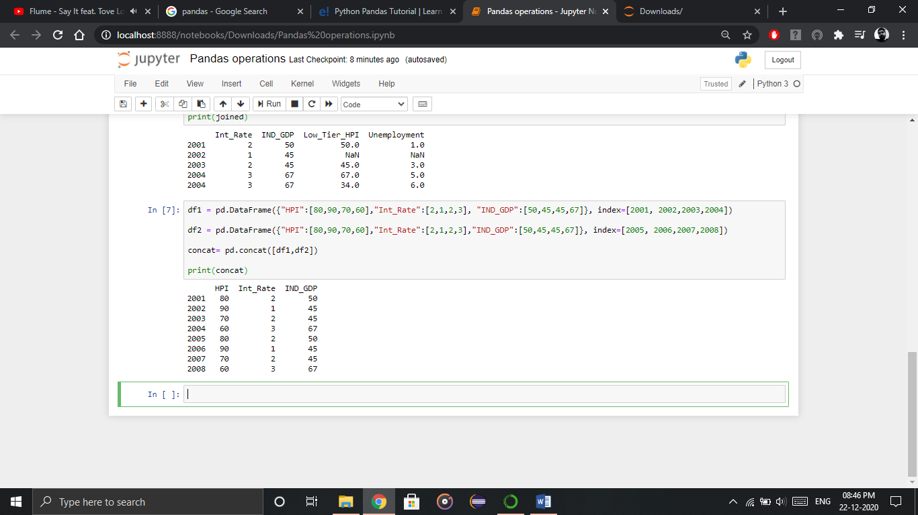

As you can see above, the two dataframes are glued together in a single dataframe, where the index starts from 2001 all the way upto 2008. Next, you can also specify axis=1 in order to join, merge or concatenate along the columns. Refer the code below:

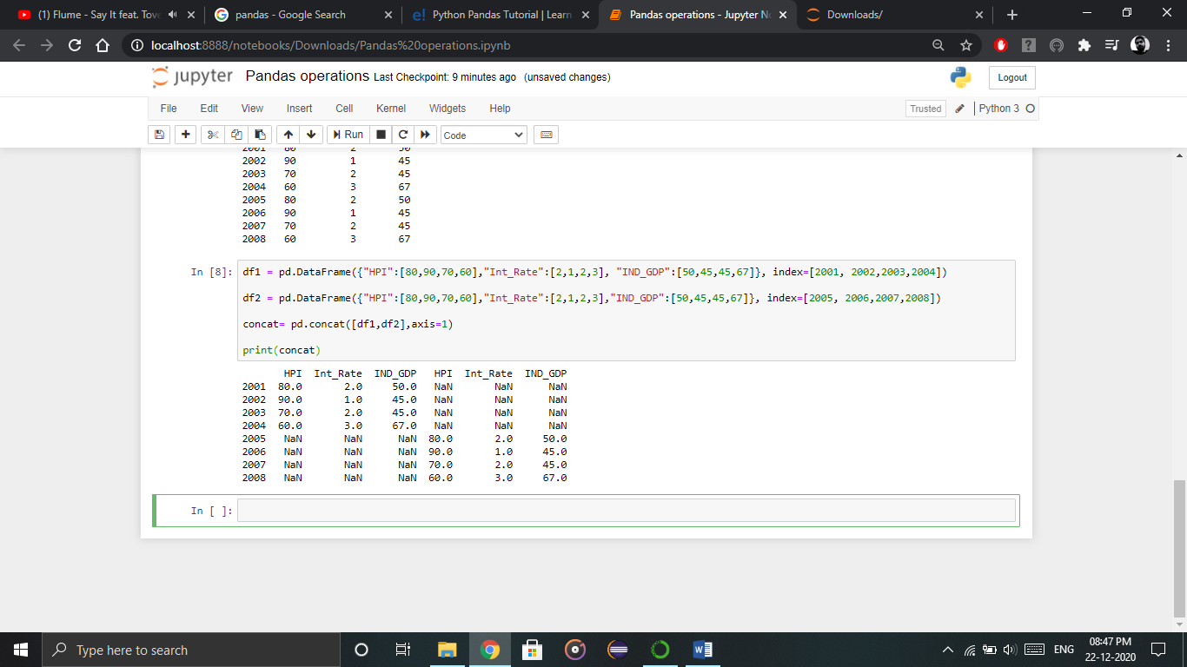

As you can above, there are bunch of missing values. This happens because the dataframes didn’t have values for all the indexes you want to concatenate on. Therefore, you should make sure that you have all the information lining up correctly when you join or concatenate on the axis.

### 

### **Change the index**

Next in python pandas tutorial, we’ll understand how to change the index values in a dataframe. For example, let us create a dataframe with some key value pairs in a dictionary and change the index values. Consider the example below:

Let us see how it actually happens:

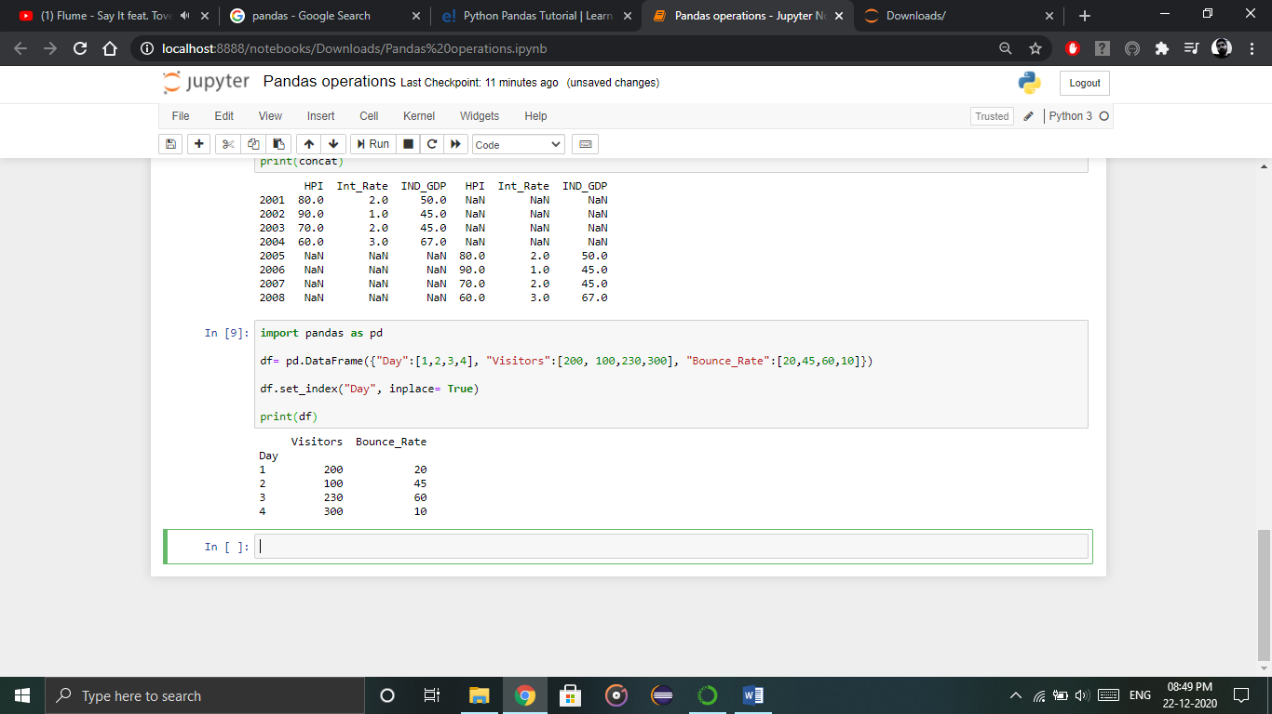

As you can notice in the output above, the index value has been changed with respect to the “Day” column.

### **Change the Column Headers**

Let us now change the headers of column in this python pandas tutorial. Let us take the same example, where I will change the column header from “Visitors” to “Users”. So, let me implement it practically.

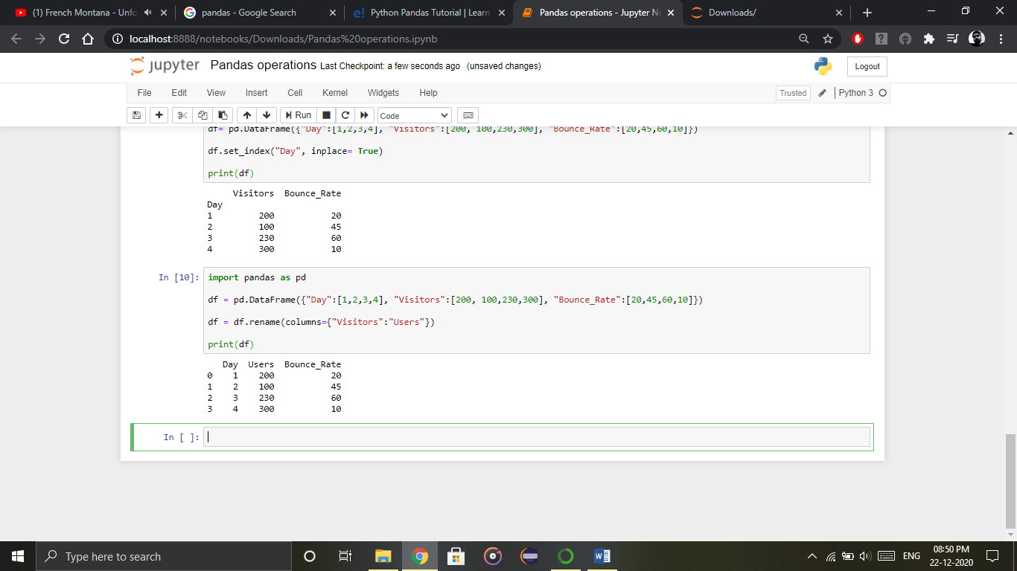

**Practice Project on Pandas**

Go through the code and try to implement it in Jupyter Notebook. Output are given, you need to write the code to get that particular output printed on the screen.

Lets use pandas for SF Salary exercise.

Get SF salaries csv data from Kaggle.

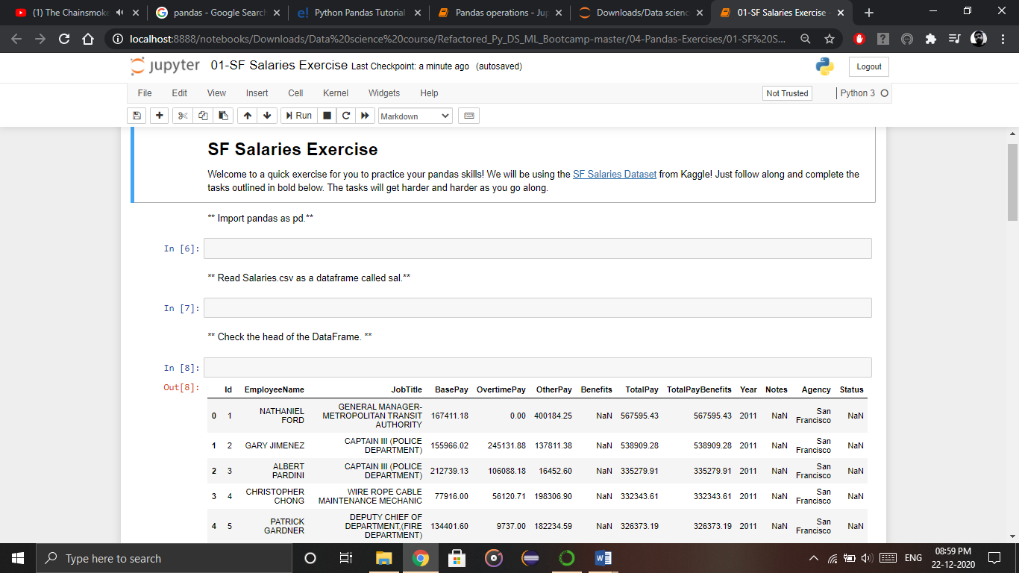

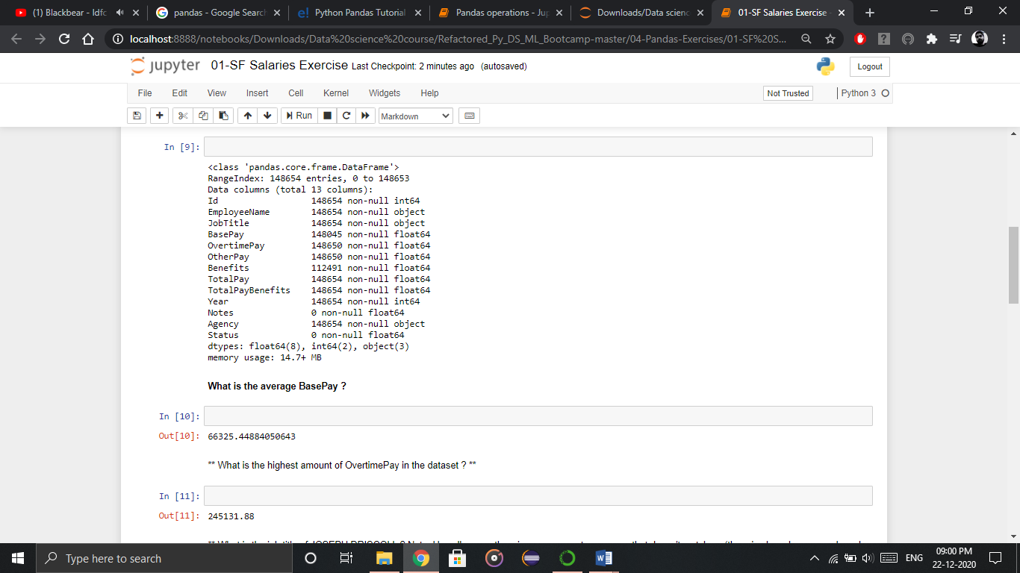

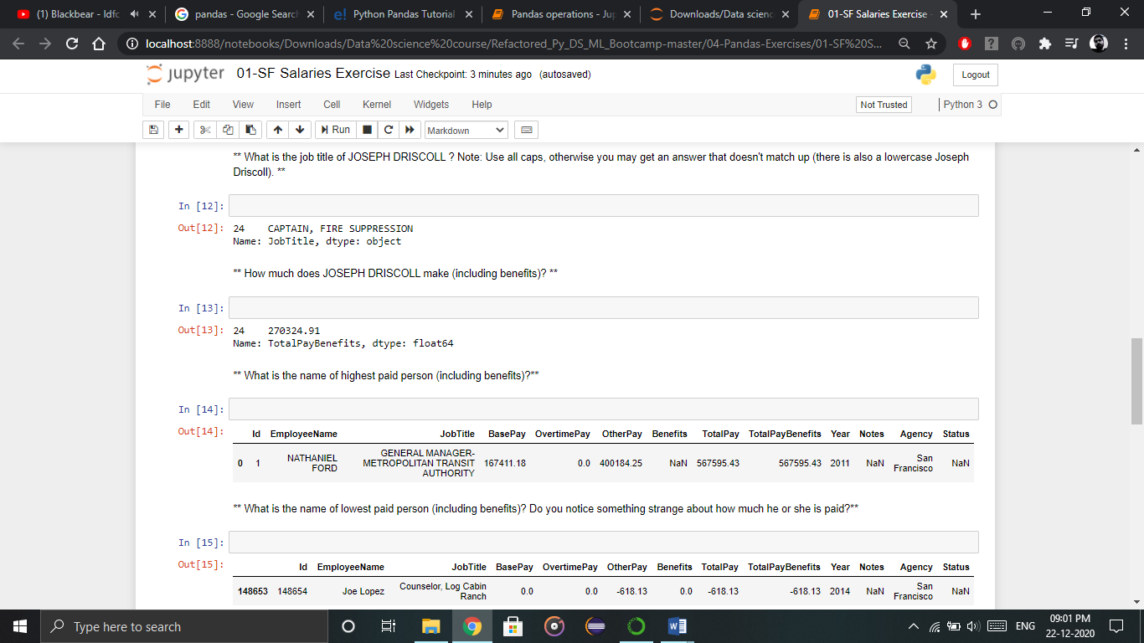

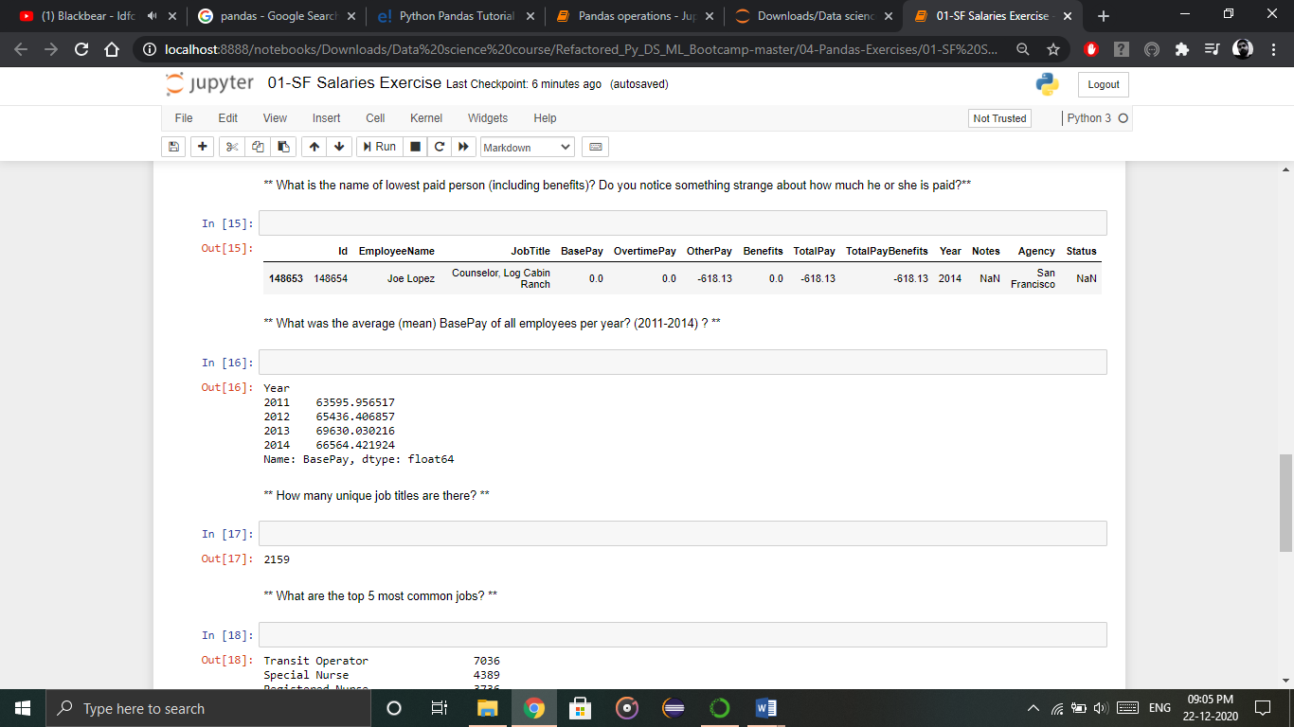

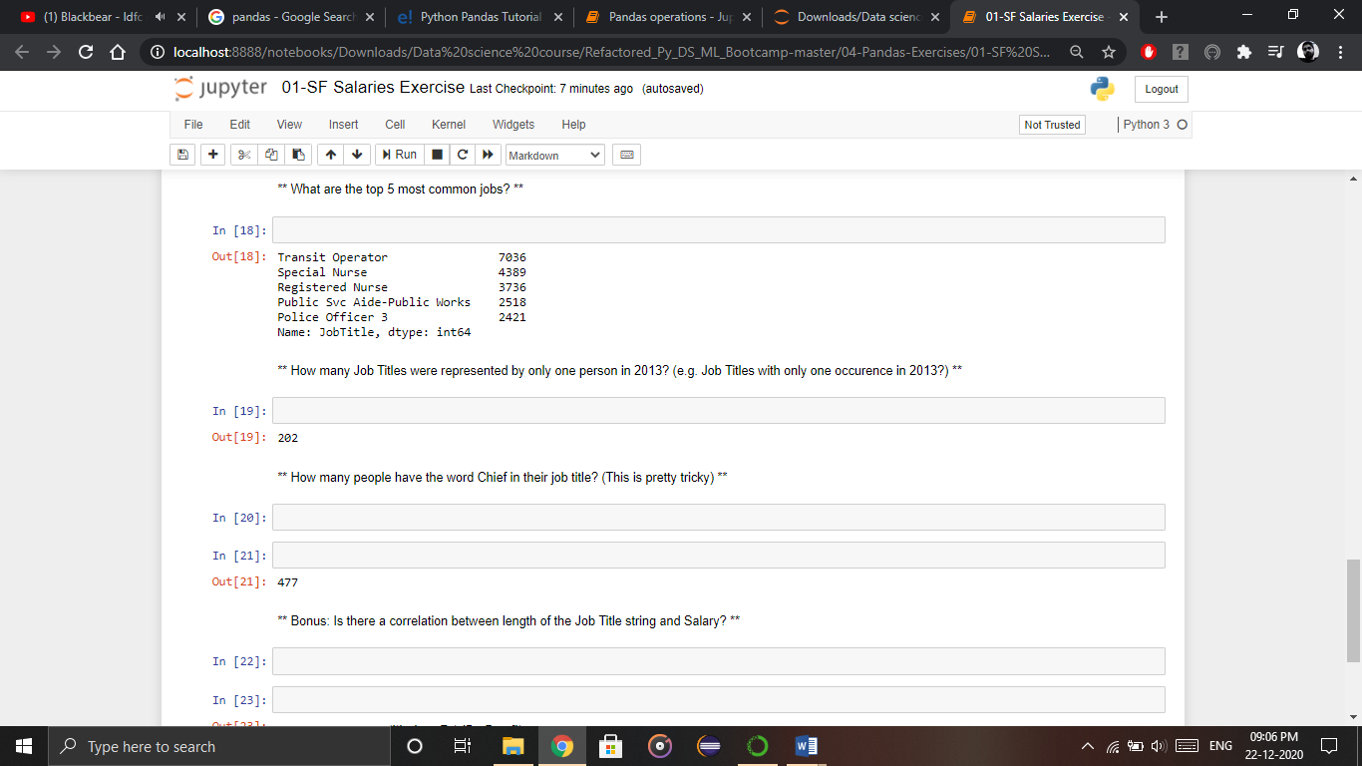

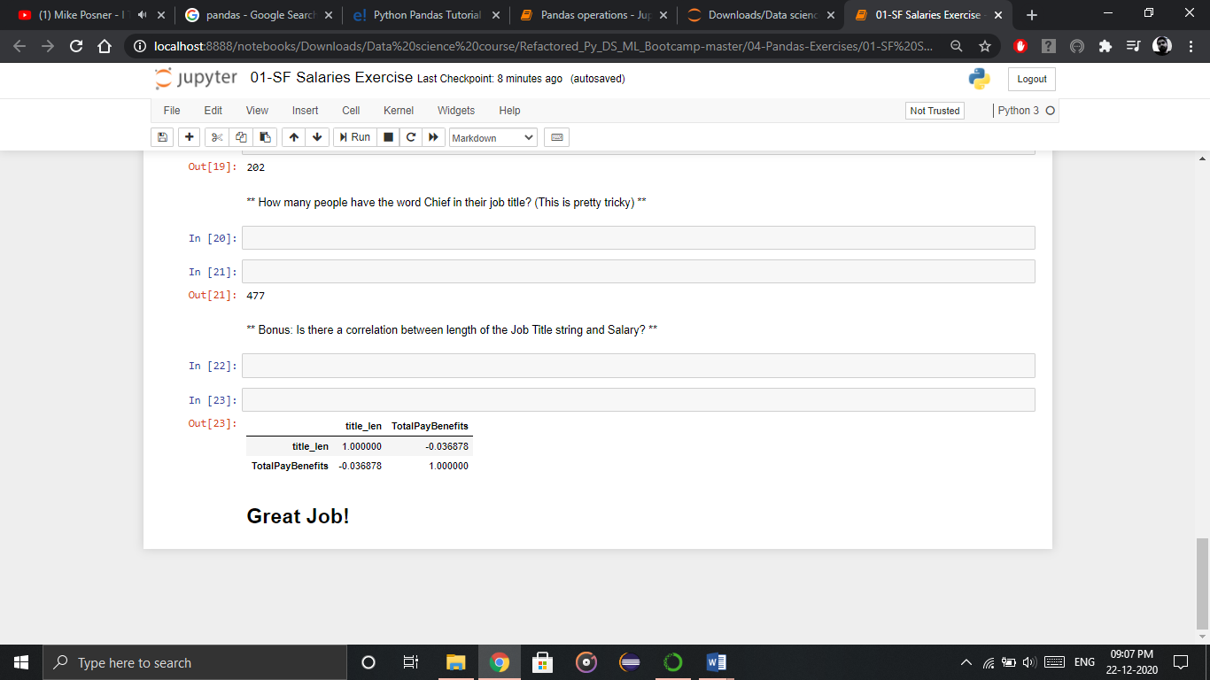

**Done!!**

**Exercise**

**MCQs**

1. Pandas is used for ______ manipulation, analysis and cleaning.
2. Value
3. Variable
4. Function
5. Data
6. ________ is yet another convenient method to combine two differently indexed dataframes into a single result dataframe.
7. Merging & Joining
8. Concatenating
9. Combine
10. Attach
11. You can select the dimension on which you want to________.
12. Join
13. Attach
14. Concatenate
15. Merge
16. ______ converts a dictionary to tables of rows and columns.
17. Dataframe
18. Datagram
19. Array
20. List
21. _____ is best suited for different kinds of data.
22. Numpy
23. Scikit
24. Pandas
25. Sklearn

**True or False**

1. Pandas is used for only ordered dataset.
2. Pandas is also used for unlabelled data.
3. In merging, you can merge two data frames to form a single data frame
4. Using Python pandas, you can perform a lot of operations with series, data frames, missing data, group by etc.
5. In order to perform slicing on data, you need a list.

**Fill in the blanks**

Concatenation, dataframes, pandas, heterogeneously-typed, joining

1. Pandas can perform tasks on tabular data with ___________ columns
2. With ______, you can perform a lot of operations with series, data frames, missing data, group by etc.
3. In merging, you can merge two _________ to form a single data frame.
4. _______ is yet another convenient method to combine two differently indexed dataframes into a single result dataframe.
5. ________ basically glues the dataframes together.

**Answer in short**

1. What is Python Pandas?
2. How to install Pandas?
3. What are python pandas operation?
4. How to change index using pandas?
5. How to perform concatenation using pandas?

**Viva Questions**

1. Define the Pandas/Python pandas?
2. Mention the different types of Data Structures in Pandas?
3. Define Series in Pandas?
4. Define DataFrame in Pandas?
5. What are the significant features of the pandas Library?
6. How will you create an empty DataFrame in Pandas?
7. How to Delete Indices, Rows or Columns From a Pandas Data Frame?
8. What is Time Series in Pandas?

**Chapter 3**

**Matplotlib**

**What Is Python Matplotlib?**

**matplotlib.pyplot** is a plotting library used for 2D graphics in python programming language. It can be used in python scripts, shell, web application servers and other graphical user interface toolkits.

**What is Matplotlib used for?**

Matplotlib is a Python Library used for plotting, this python library provides and objected-oriented APIs for integrating plots into applications.

**Is Matplotlib Included in Python?**

Matplotlib is not a part of the Standard Libraries which is installed by default when Python, there are several toolkits which are available that extend python matplotlib functionality. Some of them are separate downloads, others can be shipped with the matplotlib source code but have external dependencies.

* **Basemap**: It is a map plotting toolkit with various map projections, coastlines and political boundaries.
* **Cartopy**: It is a mapping library featuring object-oriented map projection definitions, and arbitrary point, line, polygon and image transformation capabilities.
* **Excel tools**: Matplotlib provides utilities for exchanging data with Microsoft Excel.
* **Mplot3d**: It is used for 3-D plots.
* **Natgrid**: It is an interface to the natgrid library for irregular gridding of the spaced data.

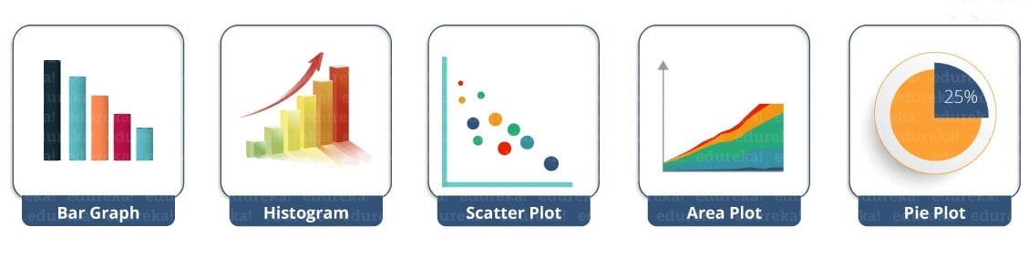

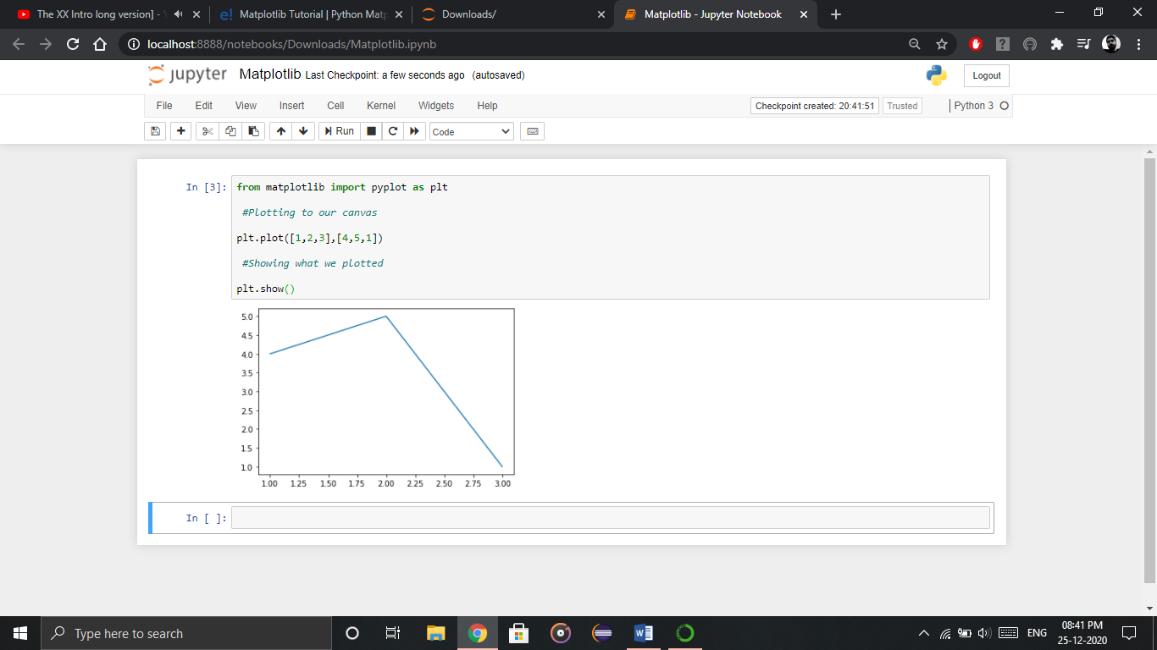

So, with three lines of code, you can generate a basic graph using python matplotlib. Simple, isn’t it?

Let us see how can we add title, labels to our graph created by python matplotlib library to bring in more meaning to it. Consider the below example:

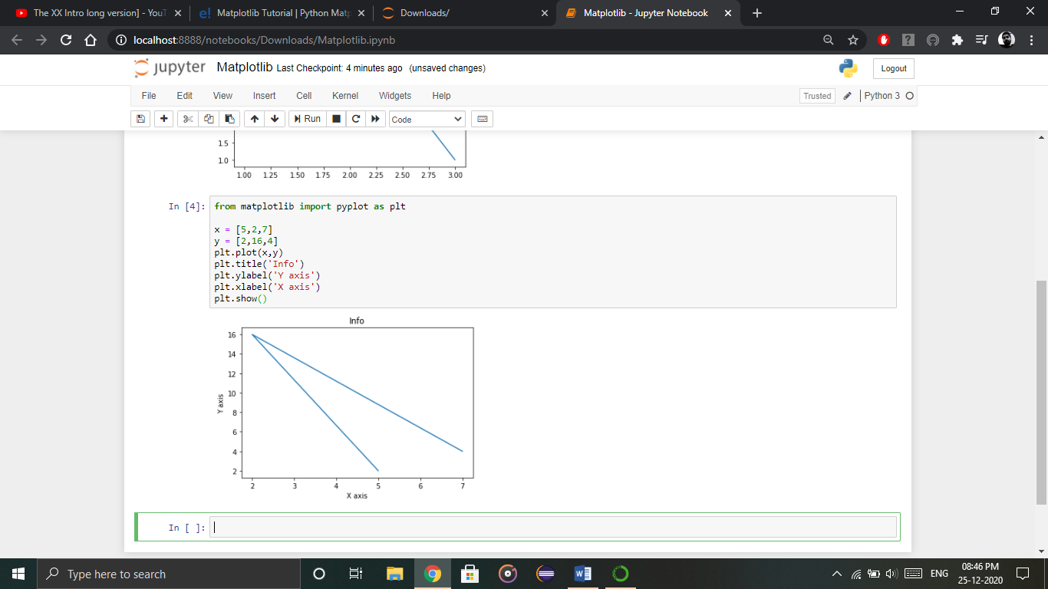

You can even try many styling techniques to create a better graph. What if you want to change the width or color of a particular line or what if you want to have some grid lines, there you need styling! So, let me show you how to add style to a graph using python matplotlib. First, you need to import the style package from python matplotlib library and then use styling functions as shown in below code:

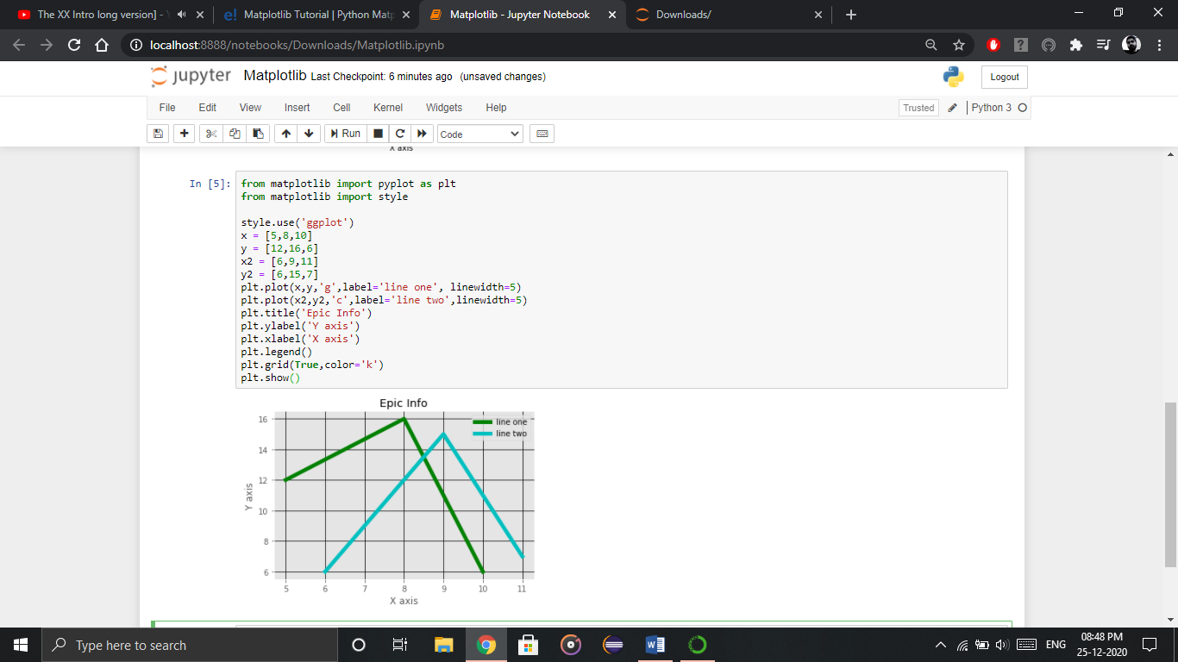

**Python Matplotlib: Bar Graph**

First, let us understand why do we need a bar graph. A bar graph uses bars to compare data among different categories. It is well suited when you want to measure the changes over a period of time. It can be represented horizontally or vertically. Also, the important thing to keep in mind is that longer the bar, greater is the value. Now, let us practically implement it using python matplotlib.

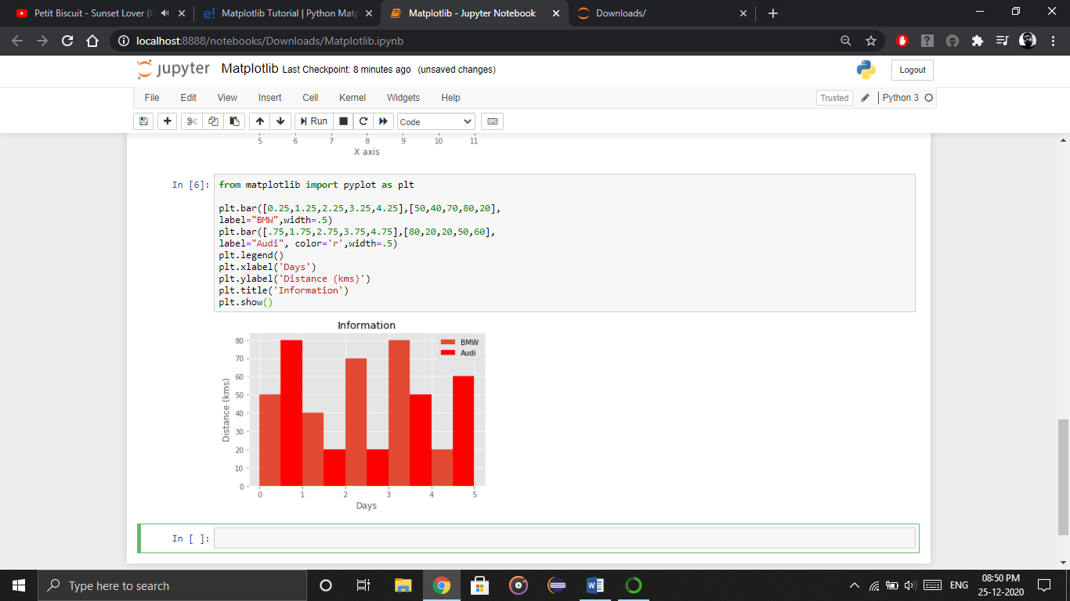

In the above plot, I have displayed the comparison between the distance covered by two cars BMW and Audi over a period of 5 days. Next, let us move on to another kind of plot using python matplotlib – Histogram.

**Python Matplotlib – Histogram**

Let me first tell you the difference between a bar graph and a histogram. Histograms are used to show a distribution whereas a bar chart is used to compare different entities. Histograms are useful when you have arrays or a very long list. Let’s consider an example where I have to plot the age of population with respect to bin. Now, bin refers to the range of values that are divided into series of intervals. Bins are usually created of the same size. In the below code, I have created the bins in the interval of 10 which means the first bin contains elements from 0 to 9, then 10 to 19 and so on.

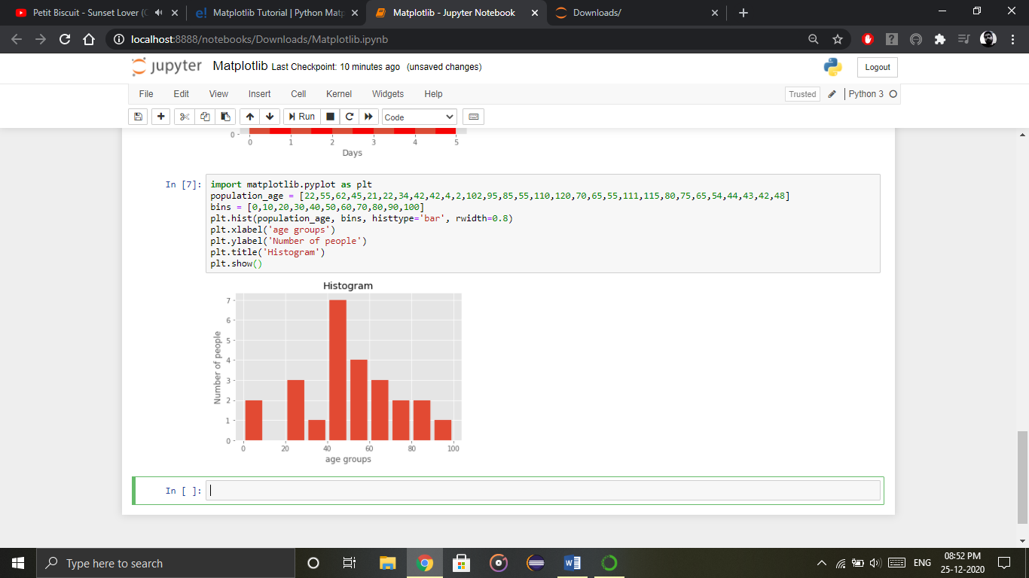

As you can see in the above plot, we got age groups with respect to the bins. Our biggest age group is between 40 and 50.

**Python Matplotlib: Scatter Plot**

Usually we need scatter plots in order to compare variables, for example, how much one variable is affected by another variable to build a relation out of it. The data is displayed as a collection of points, each having the value of one variable which determines the position on the horizontal axis and the value of other variable determines the position on the vertical axis.

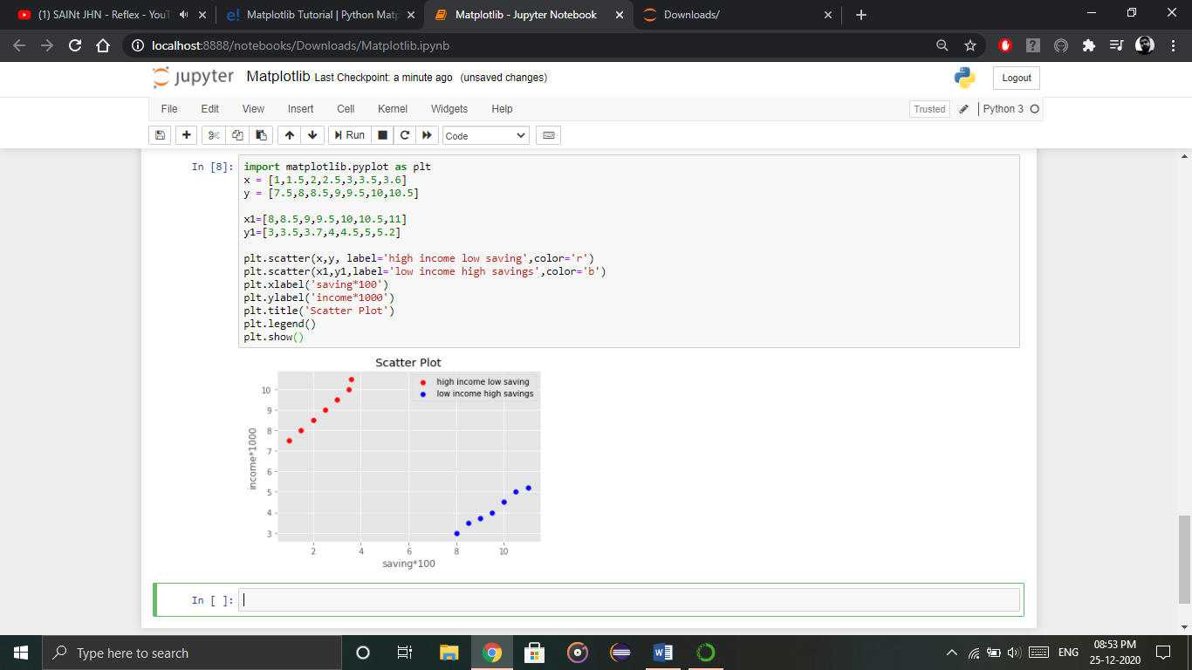

As you can see in the above graph, I have plotted two scatter plots based on the inputs specified in the above code. The data is displayed as a collection of points having ‘high income low salary’ and ‘low income high salary’.

Next, let us understand area plot or you can also say Stack plot using python matplotlib.

**Python Matplotlib : Area Plot**

Area plots are pretty much similar to the line plot. They are also known as stack plots. These plots can be used to track changes over time for two or more related groups that make up one whole category. For example, let’s compile the work done during a day into categories, say sleeping, eating, working and playing. Consider the below code:

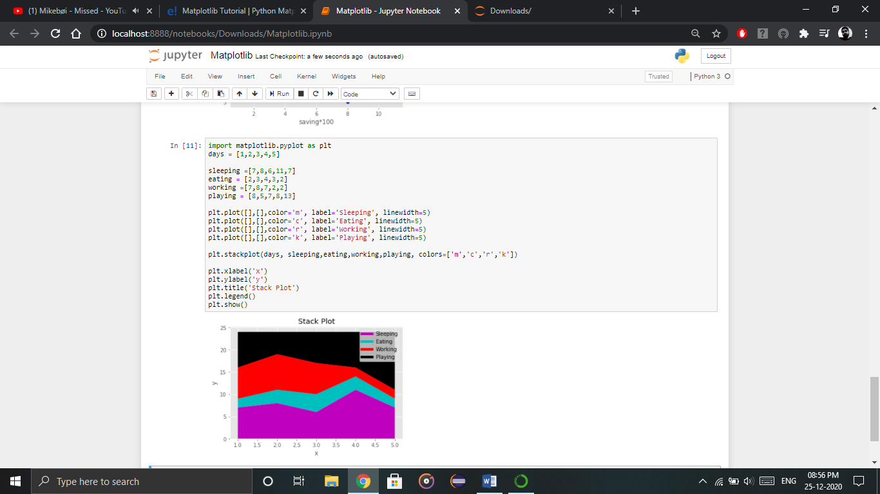

As we can see in the above image, we have time spent based on the categories. Therefore, area plot or stack plot is used to show trends over time, among different attributes. Next, let us move to our last yet most frequently used plot – Pie chart.

**Python Matplotlib: Pie Chart**

A pie chart refers to a circular graph which is broken down into segments i.e. slices of pie. It is basically used to show the percentage or proportional data where each slice of pie represents a category. Let’s have a look at the below example:

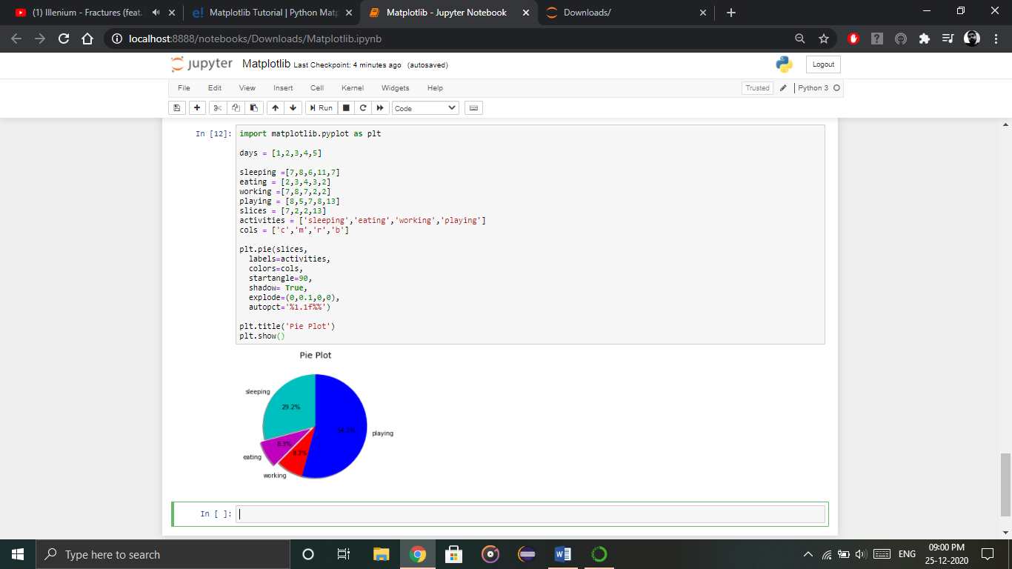

In the above pie chart, I have divided the circle into 4 sectors or slices which represents the respective category (playing, sleeping, eating and working) along with the percentage they hold. Now, if you have noticed these slices adds up to 24 hrs, but the calculation of pie slices is done automatically for you. In this way, pie charts are really useful as you don’t have to be the one who calculates the percentage or the slice of the pie.

Next in python matplotlib, let’s understand how to work with multiple plots.

**Python Matplotlib: Working With Multiple Plots**

I have discussed about multiple types of plots in python matplotlib such as bar plot, scatter plot, pie plot, area plot etc. Now, let me show you how to handle multiple plots. For this, I have to import numpy module which I discussed in my previous blog on Python Numpy. Let me implement it practically, consider the below example.

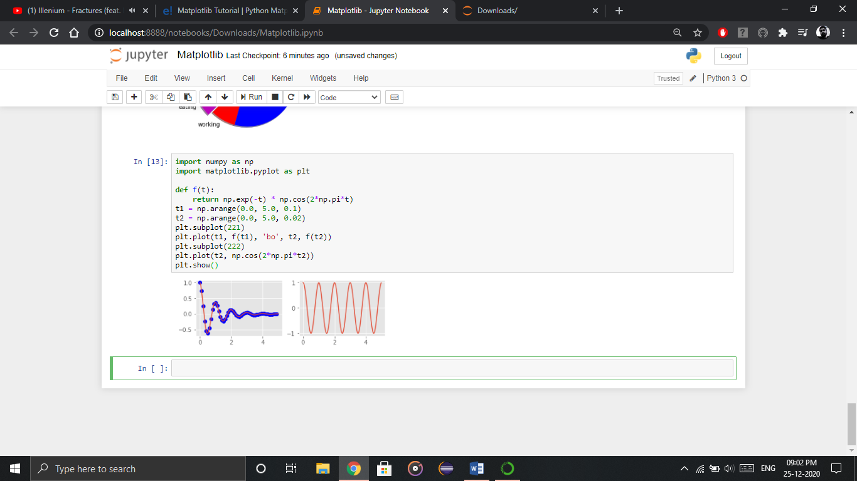

The code is pretty much similar to the previous examples that you have seen but there is one new concept here i.e. subplot. The subplot() command specifies numrow, numcol, fignum which ranges from 1 to numrows*numcols. The commas in this command are optional if numrows*numcols<10. So subplot (221) is identical to subplot (2,2,1). Therefore, subplots helps us to plot multiple graphs in which you can define it by aligning vertically or horizontally. In the above example, I have aligned it horizontally.

Apart from these, python matplotlib has some disadvantages. Some of them are listed below:

* They are heavily reliant on other packages, such as NumPy.
* It only works for python, so it is hard or impossible to be used in languages other than python. (But it can be used from Julia via PyPlot package).

**Practice Exercise on Matplotlib**

Go through the code and write the solution for the output or the problem statement asked.

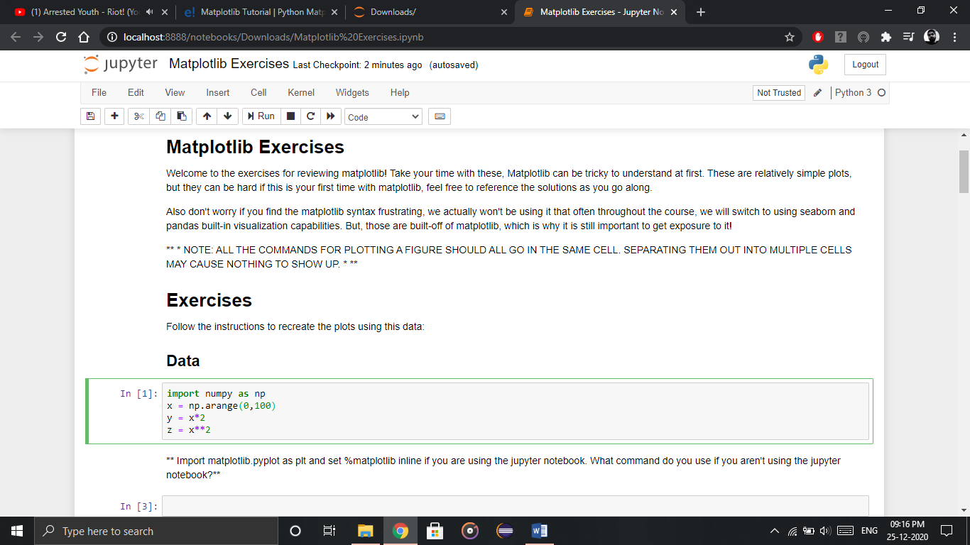

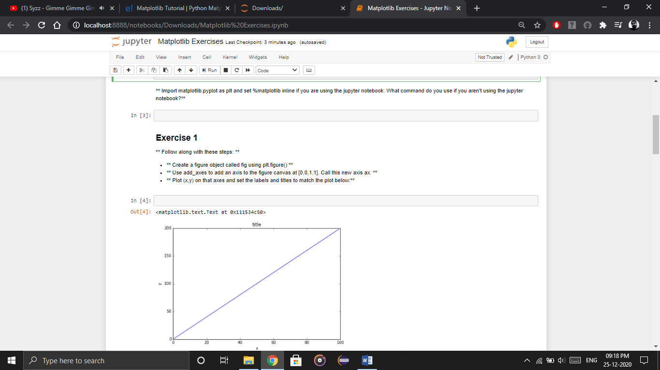

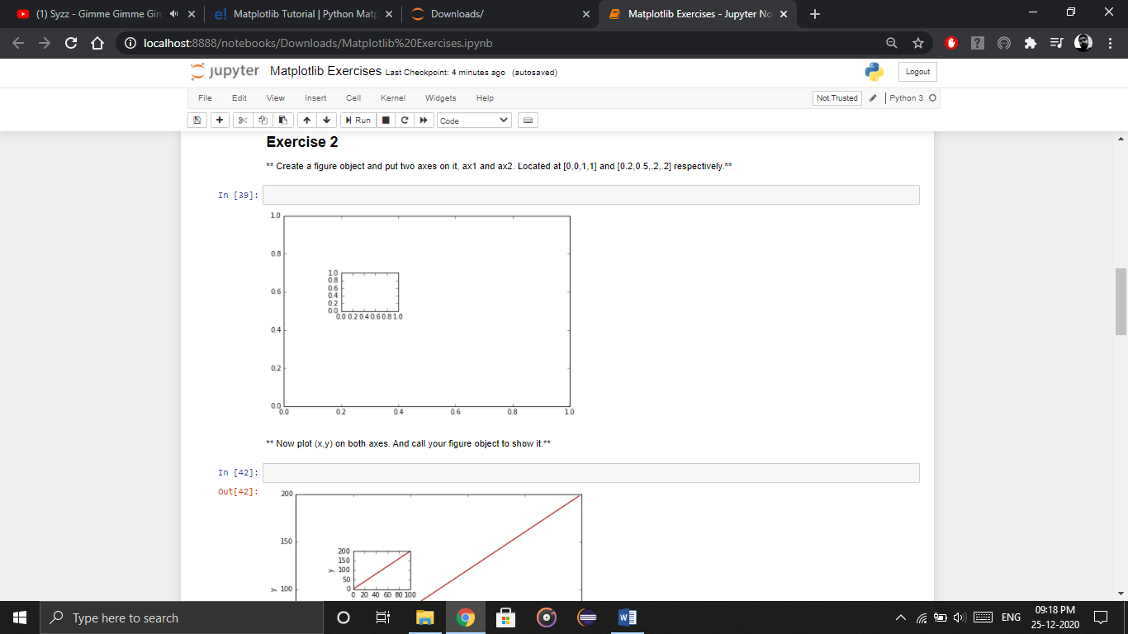

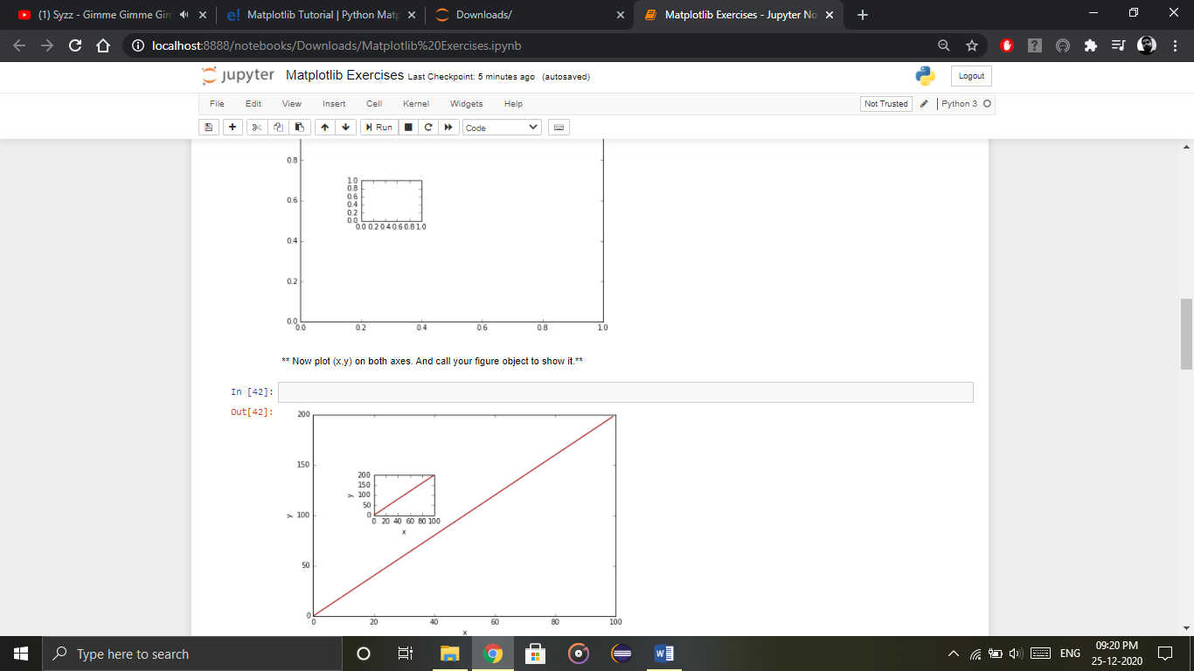

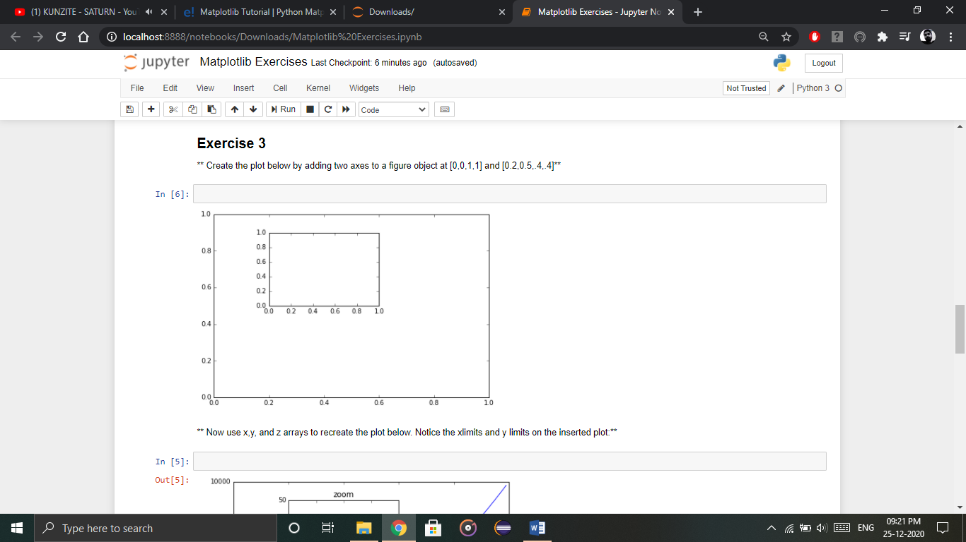

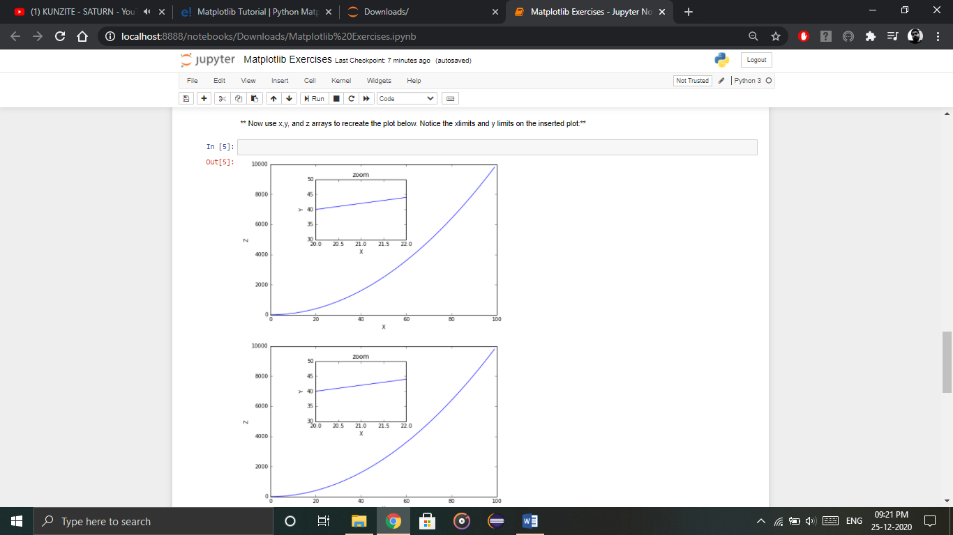

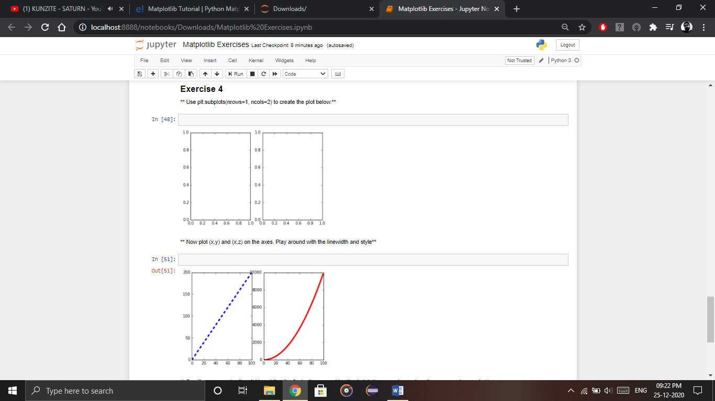

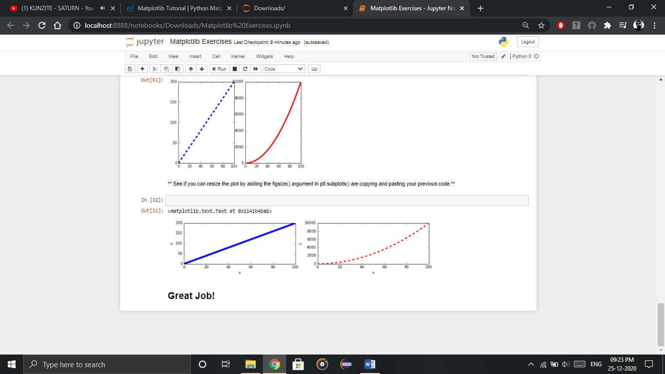

**Done!!**

**Practice Project on Matplotlib**

On the basis of the Superstore data, we are going to find the answers to the following questions:

Q1. What is the overall sales trend?

Q2. What is the overall MoM, QoQ and YoY growth?

Q3. Which are the Top 10 products by sales?

Q4. Which are the most selling products?

Q5. Which are the most profitable products?

Do the coding to plot and present answers in jupyter notebook.

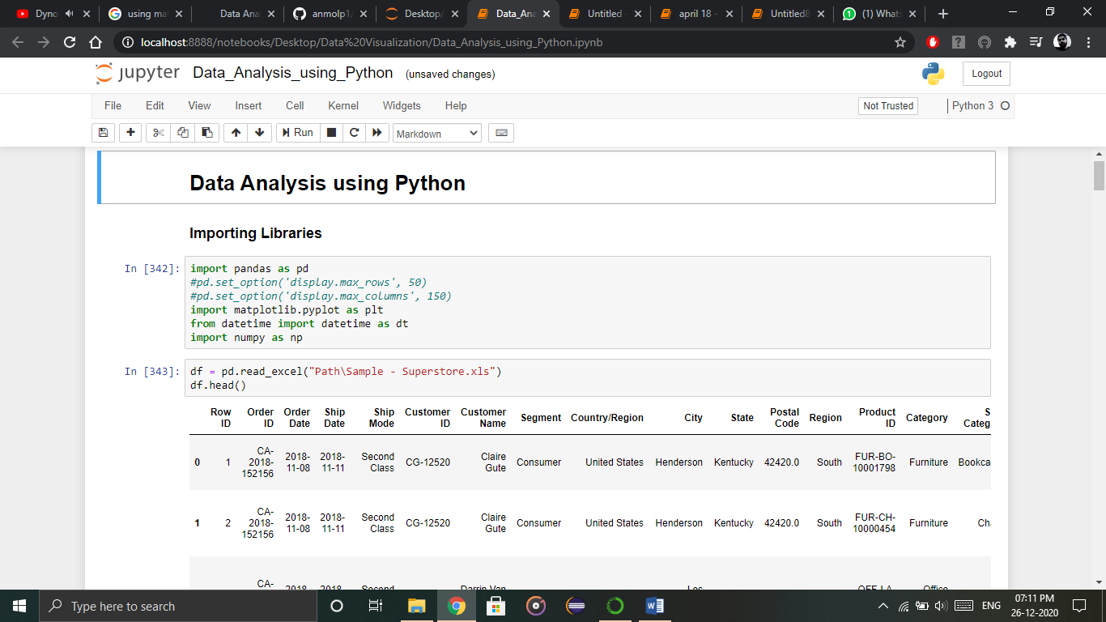

**Exercises**

**MCQs**

1. **matplotlib.pyplot** is a plotting library used for ___ graphics in python programming language.
2. 1-D
3. 2-D
4. 3-D
5. 4-D
6. Matplotlib is a Python Library used for plotting.
7. Function
8. Class
9. Library
10. Method
11. _____ is a mapping library featuring object-oriented map projection definitions, and arbitrary point, line, polygon and image transformation capabilities.
12. Cartopy
13. Basemap
14. Natgrid
15. Mplot3d
16. Matplotlib is installed by _____ in Python.
17. Users
18. Default
19. Bot
20. AI
21. ______ is used for 3-D plots.
22. Natgrid
23. Basemap
24. Mplot3D
25. Cartopy

**True or False**

1. Matplotlib cannot be used in python scripts, shell, web application servers and other graphical user interface toolkits.
2. A bar graph uses bars to compare data among different categories.
3. Histograms are used to show a distribution whereas a bar chart is used to compare similar entities.
4. In scatterplot data is displayed as a collection of points, each having the value of one variable which determines the position on the horizontal axis and the value of other variable determines the position on the vertical axis.
5. Area plots can be used to track changes over time for one or two related groups only that make up one whole category.

**Fill in the blanks**

Data, APIs, Bin, Natgrid, Proportional

1. Pie is basically used to show the percentage or ________ data where each slice of pie represents a category.
2. Matplotlib is a Python Library used for plotting, this python library provides and objected-oriented _____ for integrating plots into applications.
3. ______ is an interface the library for irregular gridding of the spaced data.
4. _____ refers to the range of values that are divided into series of intervals.
5. ______ is displayed as a collection of points, each having the value of one variable which determines the position on the horizontal axis and the value of other variable determines the position on the vertical axis.

**Answer in short**

1. What Is Python Matplotlib?
2. What is Matplotlib used for?
3. Is Matplotlib Included in Python?
4. What is bar graph in matplotlib?
5. What is histogram in matplotlib?

**Viva Questions**

1. What Is Python Matplotlib?
2. What is Matplotlib used for?
3. Is Matplotlib Included in Python?
4. Explain Python Matplotlib Bar Graph.
5. What are histograms?
6. What is Python Scatter Plot?
7. What is area plot?
8. What is a pie chart?